# CRYPTOGRAPHY AND NETWORK SECURITY LAB

**Week - 1 Stream Ciphers**

* 1. **Write a C Program to implement Shift Cipher. AIM:** To write a C Program to implement Shift Cipher. **DESCRIPTION:**

The Caesar cipher is the simplest and oldest method of cryptography. The Caesar cipher method is based on a mono-alphabetic cipher and is also called a shift cipher or additive cipher. Julius Caesar used the shift cipher (additive cipher) technique to communicate with his officers. For this reason, the shift cipher technique is called the Caesar cipher. The Caesar cipher is a kind of replacement (substitution) cipher, where all letter of plain text is replaced by another letter.A Caesar cipher is a weak method of cryptography. It can be easily hacked. It means the message encrypted by this method can be easily decrypted.

**Plaintext:** It is a simple message written by the user.

**Ciphertext:** It is an encrypted message after applying some technique.

The Caesar Cipher technique is one of the earliest and simplest methods of encryption technique. It’s simply a type of substitution cipher, i.e., each letter of a given text is replaced by a letter with a fixed number of positions down the alphabet. For example with a shift of 1, A would be replaced by B, B would become C, and so on. The method is apparently named after Julius Caesar, who apparently used it to communicate with his officials.

Thus to cipher a given text we need an integer value, known as a shift which indicates the number of positions each letter of the text has been moved down.

The encryption can be represented using modular arithmetic by first transforming the letters into numbers, according to the scheme, A = 0, B = 1,…, Z = 25. Encryption of a letter by a shift n can be described mathematically as.

(Encryption Phase with shift n) En(x) = (x+n)mod 26

(Decryption Phase with shift n) Dn(x) = (x-n)mod 26

If any case (Dn) value becomes negative (-ve), in this case, we will add 26 in the negative value.

# Where,

E denotes the encryption D denotes the decryption x denotes the letters value

n denotes the key value (shift value

# PROGRAM:

#include<stdio.h> #include<ctype.h> int main()

{

char text[500], ch; int key;

printf("Enter a message to decrypt: "); scanf("%s", text);

printf("Enter the key: "); scanf("%d", & key);

for (int i = 0; text[i] != '\0'; ++i)

{

ch = text[i];

if (isalnum(ch))

{

if (islower(ch))

{

ch = (ch - 'a' - key + 26) % 26 + 'a';

}

if (isupper(ch))

{

ch = (ch - 'A' - key + 26) % 26 + 'A';

}

if (isdigit(ch))

{

ch = (ch - '0' - key + 10) % 10 + '0';

}

}

else

{

}

printf("Invalid Message");

text[i] = ch;

}

printf("Decrypted message: %s", text); return 0;

}

# OUTPUT:

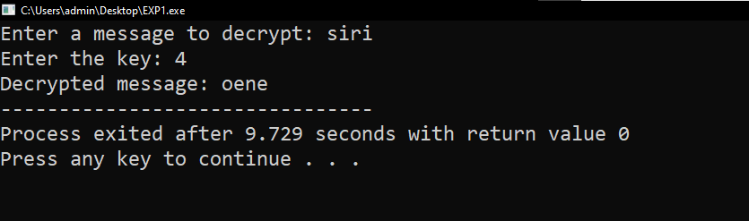

**RESULT:** Thus the implementation of Caesar cipher had been executed successfully

* 1. **Write a C Program to implement Mono-Alphabetic Substitution Cipher. AIM:** To write a C Program to implement Mono-Alphabetic Substitution Cipher. **DESCRIPTION:**

The substitution cipher is the oldest forms of encryption algorithms according to creates each character of a plaintext message and require a substitution process to restore it with a new character in the ciphertext. This substitution method is deterministic and reversible, enabling the intended message recipients to reverse-substitute ciphertext characters to retrieve the plaintext.

The specific form of substitution cipher is the Monoalphabetic Substitution Cipher, is known as “Simple Substitution Cipher”. Monoalphabetic Substitution Ciphers based on an individual key mapping function K, which consistently replaces a specific character α with a character from the mapping K (α).

A monoalphabetic cipher is any cipher in which the letters of the plain text are mapped to cipher text letters based on a single alphabetic key. Examples of monoalphabetic ciphers would include the Caesar- shift cipher, where each letter is shifted based on a numeric key, and the atbash cipher, where each letter is mapped to the letter symmetric to it about the center of the alphabet.

Monoalphabetic cipher is one where each symbol in plain text is mapped to a fixed symbol in cipher text. The relationship between a character in the plain text and the characters in the cipher text is one-to-one. Each alphabetic character of plain text is mapped onto a unique alphabetic character of a cipher text.

A stream cipher is a monoalphabetic cipher if the value of key does not depend on the position of the plain text character in the plain text stream. It includes additive, multiplicative, affine and monoalphabetic substitution cipher. Monoalphabetic Cipher is described as a substitution cipher in which the same fixed mappings from plain text to cipher letters across the entire text are used. Monoalphabetic ciphers are not that strong as compared to polyalphabetic cipher.

Monoalphabetic cipher is a substitution cipher in which for a given key, the cipher alphabet for each plain alphabet is fixed throughout the encryption process. For example, if ‘A’ is encrypted as ‘D’, for any number of occurrence in that plaintext, ‘A’ will always get encrypted to ‘D’.

# PROGRAM:

#include<stdio.h>

char monocipher_encr(char);

char alpha[27][3] = { { 'a', 'f' }, { 'b', 'a' }, { 'c', 'g' }, { 'd', 'u' }, {'e', 'n' }, { 'f', 'i' }, { 'g', 'j' }, { 'h', 'k' }, { 'i', 'l' },

{'j', 'm' }, { 'k', 'o' }, { 'l', 'p' }, { 'm', 'q' }, { 'n', 'r' }, {'o', 's' }, { 'p', 't' }, { 'q', 'v' }, { 'r', 'w' }, { 's', 'x' }, {'t', 'y' }, 'v', 'b' }, { { 'u', 'z' }, { 'w', 'c' }, { 'x', 'd' }, {'y', 'e' }, { 'z', 'h' } };

char str[20]; int main() {

char str[20], str2[20]; int i;

printf("\n Enter String:"); gets(str);

for (i = 0; str[i]; i++) {

str2[i] = monocipher_encr(str[i]);

}

str2[i] = '\0';

printf("\n Before Decryption:%s", str); printf("\n After Decryption:%s\n", str2);

}

char monocipher_encr(char a) { int i;

for (i = 0; i< 27; i++) { if (a == alpha[i][0])

break;

}

return alpha[i][1];

}

# OUTPUT:

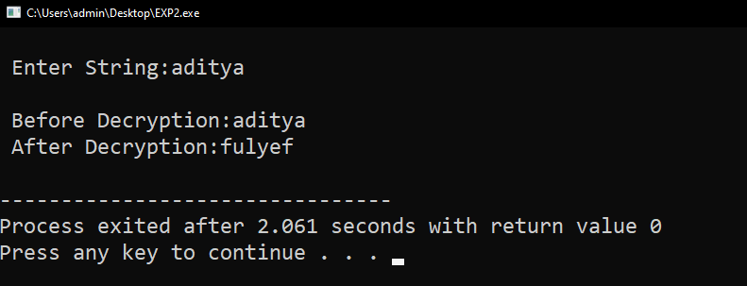

**VIVA VOICE:**

# What is cryptography?

# Cryptography is a method of protecting information and communications through the use of codes, so that only those for whom the information is intended can read and process it.

1. **What exactly are encryption and decryption?**
2. Encryption is the process by which a readable message is converted to an unreadable form to prevent unauthorized parties from reading it. Decryption is the process of converting an encrypted message back to its original (readable) format. The original message is called the plaintext message.

# What is ciphertext?

1. Ciphertext is encrypted text transformed from [plaintext](https://www.techtarget.com/searchsecurity/definition/plaintext) using an [encryption](https://www.techtarget.com/searchsecurity/definition/encryption) algorithm. Ciphertext can't be read until it has been converted into plaintext with a [key](https://www.techtarget.com/searchsecurity/definition/key). The decryption cipher is an algorithm that transforms the ciphertext back into plaintext.
2. **What is the formula for the encryption of shift cipher?**
3. A shift cipher involves replacing each letter in the message by a letter that is some fixed number of positions further along in the alphabet. We'll call this number the encryption key. It is just the length of the shift we are using.

The formula of encryption is: **En (x) = (x + n) mod 26**

# What is the formula for the decryption shift cipher?

1. A shift cipher involves replacing each letter in the message by a letter that is some fixed number of positions further along in the alphabet. We'll call this number the encryption key. It is just the length of the shift we are using.

The formula of decryption is: **Dn (x) = (xi - n) mod 26**

1. **What is the Mono-alphabetic cipher?**
2. A monoalphabetic cipher is any cipher in which the letters of the plain text are mapped to cipher text letters based on a single alphabetic key.

# What is the substitution cipher?

1. A substitution cipher merely substitutes different letters, numbers, or other characters for each character in the original text. The most straightforward example is a simplistic substitution in which each letter of the alphabet is represented by a numerical digit, starting with 1 for A.

**Week - 2 Block Ciphers**

* 1. **Write a C Program to implement one-time pad cipher. AIM:** To write a C Program to implement one-time pad cipher. **DESCRIPTION:**

One-time pad cipher is a type of Vignere cipher which includes the following features −

* + - It is an unbreakable cipher.
    - The key is exactly same as the length of message which is encrypted.
    - The key is made up of random symbols.
    - As the name suggests, key is used one time only and never used again for any other message to be encrypted.

Due to this, encrypted message will be vulnerable to attack for a cryptanalyst. The key used for a one-time pad cipher is called **pad**, as it is printed on pads of paper.

The two requirements for the One-Time pad are

* The key should be randomly generated as long as the size of the message.
* The key is to be used to encrypt and decrypt a single message, and then it is discarded.

So encrypting every new message requires a new key of the same length as the new message in one-time pad.

The ciphertext generated by the One-Time pad is random, so it does not have any statistical relation with the plain text.

Encryption

To encrypt a letter, a user needs to write a key underneath the plaintext. The plaintext letter is placed on the top and the key letter on the left. The cross section achieved between two letters is the plain text. It is described in the example below :

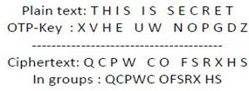

Decryption

To decrypt a letter, user takes the key letter on the left and finds cipher text letter in that row. The plain text letter is placed at the top of the column where the user can find the cipher text letter.

# PROGRAM:

#include<stdio.h> #include<string.h> #include<ctype.h> main()

{

//All the text which ever entered is converted to upper and without spaces int i,j,len1,len2,numstr[100],numkey[100],numcipher[100];

char str[100],key[100],cipher[100]; printf("Enter a string text to encrypt\n"); gets(str);

for(i=0,j=0;i<strlen(str);i++)

{

if(str[i]!=' ')

{

str[j]=toupper(str[i]); j++;

}

}

str[j]='\0';

//obtaining numerical plain text ex A-0,B-1,C-2 for(i=0;i<strlen(str);i++)

{

numstr[i]=str[i]-'A';

}

printf("Enter key string of random text\n"); gets(key);

for(i=0,j=0;i<strlen(key);i++)

{

if(key[i]!=' ')

{

key[j]=toupper(key[i]); j++;

}

}

key[j]='\0';

//obtaining numerical one time pad(OTP) or key for(i=0;i<strlen(key);i++)

{

numkey[i]=key[i]-'A';

}

for(i=0;i<strlen(str);i++)

{

numcipher[i]=numstr[i]+numkey[i];

}

//To loop the number within 25 i.e if addition of numstr and numkey is 27 then numcipher should be 1 for(i=0;i<strlen(str);i++)

{

if(numcipher[i]>25)

{

numcipher[i]=numcipher[i]-26;

}

}

printf("One Time Pad Cipher text is\n"); for(i=0;i<strlen(str);i++)

{

printf("%c",(numcipher[i]+'A'));

}

printf("\n");

}

# OUTPUT:

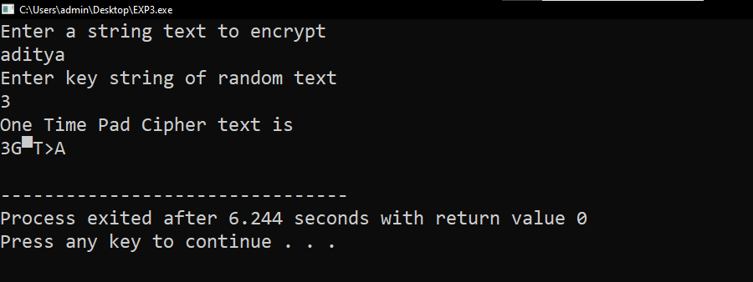

* 1. **Write a C Program to implement vernam cipher. AIM:** To write a C Program to implement vernam cipher. **DESCRIPTION:**

Vernam Cipher is a method of encrypting alphabetic text. It is one of the Substitution techniques for converting plain text into cipher text. In this mechanism we assign a number to each character of the Plain-Text, like (a = 0, b

= 1, c = 2, … z = 25).

Method to take key: In the Vernam cipher algorithm, we take a key to encrypt the plain text whose length should be equal to the length of the plain text.

# Encryption Algorithm:

* + - Assign a number to each character of the plain-text and the key according to alphabetical order.
    - Bitwise XOR both the number (Corresponding plain-text character number and Key character number).
    - Subtract the number from 26 if the resulting number is greater than or equal to 26, if it isn’t then leave it.
    - E (Pi , Ki) = Pi (XOR) Ki

# EXAMPLE:

**Plain-Text:** O A K

**Key:** S O N

**O ==>** 14 = 0 1 1 1 0

**S ==>** 18 = 1 0 0 1 0

**Bitwise XOR Result**: 1 1 1 0 0 = 28

Since the resulting number is greater than 26, subtract 26 from it. Then convert the Cipher-Text character number to the Cipher-Text character.

28 - 26 = 2 ==> C

# CIPHER-TEXT: C

**Decryption Process**

The process of decrypting the ciphertext to convert it back into plain text is performed in the same way as the encryption process. Therefore, the formula for decryption of the text under Vernam cipher is as follows,

D (Ci , Ki) = Ci (XOR) Ki

# PROGRAM:

#include<stdio.h> #include<string.h> #include<stdlib.h>

void encrypt(char *plaintext, char *key,char *ciphertext)

{

int i;

for(i=0; i<strlen(plaintext);i++)

{

ciphertext[i] = plaintext[i] ^ key[i];

}

}

void decrypt(char *ciphertext , char *key , char *plaintext)

{

int i;

for(i=0; i<strlen(ciphertext);i++)

{

plaintext[i] = ciphertext[i] ^ key[i];

}

}

int main(int argc, char *argv[])

{

char plaintext[100]; char key[100];

char ciphertext[100];

printf("Enter Plaintext "); scanf("%s",plaintext); printf("Enter Key "); scanf("%s",key); encrypt(plaintext,key,ciphertext);

printf("Ciphertext : %s\n",ciphertext); decrypt(ciphertext,key,plaintext); printf("Plaintext: %s\n",plaintext); return 0;

}

# OUTPUT:

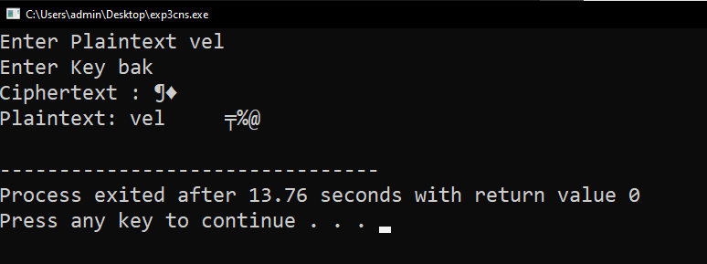

**VIVA VOICE:**

# What is the one-time pad cipher?

# In cryptography, a one-time pad is a system in which a randomly generated private key is used only once to encrypt a message that is then decrypted by the receiver using a matching one-time pad and key.

1. **What exactly is the Vignere cipher?**
2. The Vigenère cipher is a method of encrypting alphabetic text by using a series of interwoven Caesar ciphers, based on the letters of a keyword.

# What is ciphertext?

1. In cryptography, ciphertext or cyphertext is the result of encryption performed on plaintext using an algorithm, called a cipher.
2. **Why is the one-time pad cipher is unbreakable?**
3. A One Time Pad (OTP) is the only potentially unbreakable encryption method. Plain text encrypted using an OTP cannot be retrieved without the encrypting key. However, there are several key conditions that must be met by the user of a one time pad cipher, or the cipher can be compromised.

If the key is random and never re-used, an OTP is provably unbreakable. Any ciphertext can be decrypted to any message of the same length by using the appropriate key. Thus, the actual original message cannot be determined from ciphertext alone, as all possible plaintexts are equally likely.

# What is the vernam cipher?

1. The Vernam cipher is a substitution cipher where each plain text character is encrypted using its own key. This key — or key stream — is randomly generated or is taken from a one-time pad, e.g. a page of a book. The key must be equal in length to the plain text message.
2. **What is the formula for encrypting the text in the vernam cipher?**
3. The formula for encrypting text in the Vernam cipher is: C = (M + K) mod 26, where C is the ciphertext, M is the plaintext, and K is the secret key.

# What is the technique used in the vernam cipher and the one-time pad cipher?

# It is a method of encrypting alphabetic plain text. It is one of the Substitution techniques which converts plain text into ciphertext.

**Week - 3 Symmetric Cryptography**

* 1. **Write a C Program to implement DES Algorithm. AIM :** To write a C Program to implement DES algorithm. **DESCRIPTION:**

The Data Encryption Standard (DES) is a symmetric-key block cipher published by the National Institute of Standards and Technology (NIST).

DES is an implementation of a Feistel Cipher. It uses 16 round Feistel structure. The block size is 64-bit. Though, key length is 64-bit, DES has an effective key length of 56 bits, since 8 of the 64 bits of the key are not used by the encryption algorithm (function as check bits only).

Data encryption standard (DES) has been found vulnerable to very powerful attacks and therefore, the popularity of DES has been found slightly on the decline. DES is a block cipher and encrypts data in blocks of size of 64 bits each, which means 64 bits of plain text go as the input to DES, which produces 64 bits of ciphertext. The same algorithm and key are used for encryption and decryption, with minor differences. The key length is 56 bits.

Since DES is based on the Feistel Cipher, all that is required to specify DES is −

* + - Round function
    - Key schedule
    - Any additional processing − Initial and final permutation

# Initial and Final Permutation

The initial and final permutations are straight Permutation boxes (P-boxes) that are inverses of each other. They have no cryptography significance in DES.

# Round Function

The heart of this cipher is the DES function, *f*. The DES function applies a 48-bit key to the rightmost 32 bits to produce a 32-bit output.

# Expansion Permutation Box

Since right input is 32-bit and round key is a 48-bit, we first need to expand right input to 48 bits. The graphically depicted permutation logic is generally described as table in DES.

# XOR (Whitener)

After the expansion permutation, DES does XOR operation on the expanded right section and the round key. The round key is used only in this operation.

# Substitution Boxes

The S-boxes carry out the real mixing (confusion). DES uses 8 S-boxes, each with a 6-bit input and a 4-bit output.

# PROGRAM:

#include<stdio.h> int main()

{

int i, cnt=0, p8[8]={6,7,8,9,1,2,3,4};

int p10[10]={6,7,8,9,10,1,2,3,4,5};

char input[11], k1[10], k2[10], temp[11]; char LS1[5], LS2[5];

//k1, k2 are for storing interim keys

//p8 and p10 are for storing permutation key

//Read 10 bits from user... printf("Enter 10 bits input:"); scanf("%s",input);

input[10]='\0';

//Applying p10... for(i=0; i<10; i++)

{

cnt = p10[i];

temp[i] = input[cnt-1];

}

temp[i]='\0';

printf("\nYour p10 key is :"); for(i=0; i<10; i++)

{ printf("%d,",p10[i]);

}

printf("\nBits after p10 :"); puts(temp);

//Performing LS-1 on first half of temp

for(i=0; i<5; i++)

{

if(i==4) temp[i]=temp[0]; else temp[i]=temp[i+1];

}

//Performing LS-1 on second half of temp for(i=5; i<10; i++)

{

if(i==9) temp[i]=temp[5]; else temp[i]=temp[i+1];

}

printf("Output after LS-1 :"); puts(temp);

printf("\nYour p8 key is :"); for(i=0; i<8; i++){ printf("%d,",p8[i]);

}

//Applying p8... for(i=0; i<8; i++)

{

cnt = p8[i];

k1[i] = temp[cnt-1];

}

printf("\nYour key k1 is :");

puts(k1);

//This program can be extended to generate k2 as per DES algorithm.

}

# OUTPUT:

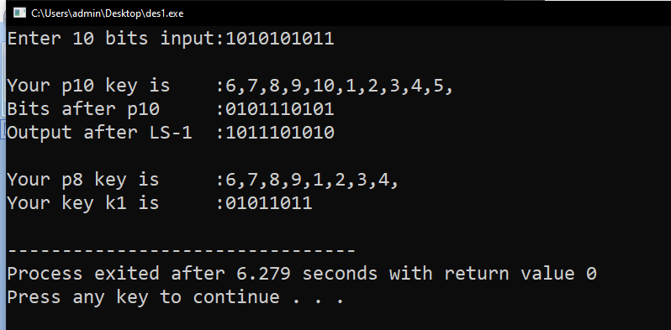

* 1. **Write a C Program to implement AES algorithm. AIM :** To write a C Program to implement AES algorithm. **DESCRIPTION:**

The more popular and widely adopted symmetric encryption algorithm likely to be encountered nowadays is the Advanced Encryption Standard (AES). It is found at least six time faster than triple DES.

A replacement for DES was needed as its key size was too small. With increasing computing power, it was considered vulnerable against exhaustive key search attack. Triple DES was designed to overcome this drawback but it was found slow.

The features of AES are as follows −

* + - Symmetric key symmetric block cipher
    - 128-bit data, 128/192/256-bit keys
    - Stronger and faster than Triple-DES
    - Provide full specification and design details
    - Software implementable in C and Java

**Encryption Process:** Here, we restrict to description of a typical round of AES encryption. Each round comprise of four sub-processes. The first round process is depicted below –

# Byte Substitution (SubBytes)

The 16 input bytes are substituted by looking up a fixed table (S-box) given in design. The result is in a matrix of four rows and four columns.

# Shiftrows

Each of the four rows of the matrix is shifted to the left. Any entries that ‘fall off’ are re-inserted on the right side of row.

# MixColumns

Each column of four bytes is now transformed using a special mathematical function. This function takes as input the four bytes of one column and outputs four completely new bytes, which replace the original column. The result is another new matrix consisting of 16 new bytes.

# Addroundkey

The 16 bytes of the matrix are now considered as 128 bits and are XORed to the 128 bits of the round key. If this is the last round then the output is the ciphertext. Otherwise, the resulting 128 bits are interpreted as 16 bytes and we begin another similar round.

**Decryption Process:**The process of decryption of an AES ciphertext is similar to the encryption process in the reverse order. Each round consists of the four processes conducted in the reverse order −

* + - * Add round key
      * Mix columns
      * Shift rows
      * Byte substitution

# PROGRAM :

**aes.h:**

#include <stdint.h> #include <stddef.h>

/* Define constants and sbox */ #define Nb 4

#define Nk(keysize) ((int)(keysize / 32)) #define Nr(keysize) ((int)(Nk(keysize) + 6))

/* State and key types */ typedef uint8_t** State; typedef uint8_t* Key;

/* My additional methods */

void encrypt(char* plain, char* key); void decrypt(char* cipher, char* key); State* toState(uint8_t* input); uint8_t** fromState(State* state); void freeState(State* state);

void stringToBytes(char* str, uint8_t* bytes);

/* AES main methods */

uint8_t** Cipher(uint8_t* input, uint8_t* keySchedule, size_tkeySize); uint8_t** InvCipher(uint8_t* input, uint8_t* w, size_tkeySize);

/* AES sub-methods */

void _SubBytes(State* state, const uint8_t* box); void SubBytes(State* state);

void InvSubBytes(State* state);

void _ShiftRows(State* state, int multiplier); void ShiftRows(State* state);

void InvShiftRows(State* state); void MixColumns(State* state); void InvMixColumns(State* state);

void AddRoundKey(State* state, uint8_t* roundKey);

void KeyExpansion(uint8_t* key, uint8_t* keySchedule, size_tkeySize);

/* AES sub-sub-methods and round constant array */ uint8_t* SubWord(uint8_t* a);

uint8_t* RotWord(uint8_t* a); uint8_t* Rcon(int a);

/* AES helper methods */

uint8_t* xorWords(uint8_t* a, uint8_t* b); uint8_t* copyWord(uint8_t* start); uint8_t* getWord(uint8_t* w, int i);

uint8_t galoisMultiply(uint8_t a, uint8_t b);

**const.c :**

#include <stdint.h>

const uint8_t sbox[] = {0x63, 0x7c, 0x77, 0x7b, 0xf2, 0x6b, 0x6f, 0xc5, 0x30, 0x01, 0x67, 0x2b, 0xfe, 0xd7, 0xab, 0x76, 0xca, 0x82, 0xc9, 0x7d, 0xfa, 0x59, 0x47, 0xf0, 0xad, 0xd4, 0xa2, 0xaf, 0x9c, 0xa4, 0x72, 0xc0, 0xb7, 0xfd, 0x93, 0x26, 0x36, 0x3f, 0xf7, 0xcc, 0x34, 0xa5, 0xe5, 0xf1, 0x71, 0xd8, 0x31, 0x15, 0x04, 0xc7, 0x23, 0xc3, 0x18, 0x96, 0x05, 0x9a, 0x07, 0x12, 0x80, 0xe2, 0xeb, 0x27, 0xb2, 0x75,

0x09, 0x83, 0x2c, 0x1a, 0x1b, 0x6e, 0x5a, 0xa0, 0x52, 0x3b, 0xd6, 0xb3, 0x29, 0xe3, 0x2f, 0x84, 0x53, 0xd1, 0x00, 0xed, 0x20, 0xfc, 0xb1, 0x5b, 0x6a, 0xcb, 0xbe, 0x39, 0x4a, 0x4c, 0x58, 0xcf, 0xd0, 0xef, 0xaa, 0xfb, 0x43, 0x4d, 0x33, 0x85, 0x45, 0xf9, 0x02, 0x7f, 0x50, 0x3c, 0x9f, 0xa8, 0x51, 0xa3, 0x40, 0x8f, 0x92, 0x9d, 0x38, 0xf5, 0xbc, 0xb6, 0xda, 0x21, 0x10, 0xff, 0xf3, 0xd2, 0xcd, 0x0c, 0x13, 0xec, 0x5f, 0x97, 0x44, 0x17, 0xc4, 0xa7, 0x7e, 0x3d, 0x64, 0x5d, 0x19, 0x73, 0x60, 0x81, 0x4f, 0xdc, 0x22, 0x2a, 0x90, 0x88, 0x46, 0xee, 0xb8, 0x14, 0xde, 0x5e, 0x0b, 0xdb, 0xe0, 0x32, 0x3a, 0x0a, 0x49, 0x06, 0x24, 0x5c, 0xc2, 0xd3, 0xac, 0x62, 0x91, 0x95, 0xe4, 0x79, 0xe7, 0xc8, 0x37, 0x6d, 0x8d, 0xd5, 0x4e, 0xa9, 0x6c, 0x56, 0xf4, 0xea, 0x65, 0x7a, 0xae, 0x08, 0xba, 0x78, 0x25, 0x2e, 0x1c, 0xa6, 0xb4, 0xc6, 0xe8, 0xdd, 0x74, 0x1f, 0x4b, 0xbd, 0x8b, 0x8a, 0x70, 0x3e, 0xb5, 0x66, 0x48, 0x03, 0xf6, 0x0e, 0x61, 0x35, 0x57, 0xb9, 0x86, 0xc1, 0x1d, 0x9e, 0xe1, 0xf8, 0x98, 0x11, 0x69, 0xd9, 0x8e, 0x94, 0x9b, 0x1e, 0x87, 0xe9, 0xce, 0x55, 0x28, 0xdf, 0x8c, 0xa1, 0x89, 0x0d, 0xbf, 0xe6, 0x42, 0x68, 0x41, 0x99, 0x2d, 0x0f, 0xb0, 0x54, 0xbb, 0x16};

const uint8_t isbox[] = {0x52, 0x09, 0x6a, 0xd5, 0x30, 0x36, 0xa5, 0x38, 0xbf, 0x40, 0xa3, 0x9e, 0x81, 0xf3, 0xd7, 0xfb, 0x7c, 0xe3, 0x39, 0x82, 0x9b, 0x2f, 0xff, 0x87, 0x34, 0x8e, 0x43, 0x44, 0xc4, 0xde, 0xe9, 0xcb, 0x54, 0x7b, 0x94, 0x32, 0xa6, 0xc2, 0x23, 0x3d, 0xee, 0x4c, 0x95, 0x0b, 0x42, 0xfa, 0xc3, 0x4e, 0x08, 0x2e, 0xa1, 0x66, 0x28, 0xd9, 0x24, 0xb2, 0x76, 0x5b, 0xa2, 0x49, 0x6d, 0x8b, 0xd1, 0x25,

0x72, 0xf8, 0xf6, 0x64, 0x86, 0x68, 0x98, 0x16, 0xd4, 0xa4, 0x5c, 0xcc, 0x5d, 0x65, 0xb6, 0x92, 0x6c, 0x70, 0x48, 0x50, 0xfd, 0xed, 0xb9, 0xda, 0x5e, 0x15, 0x46, 0x57, 0xa7, 0x8d, 0x9d, 0x84, 0x90, 0xd8, 0xab, 0x00, 0x8c, 0xbc, 0xd3, 0x0a, 0xf7, 0xe4, 0x58, 0x05, 0xb8, 0xb3, 0x45, 0x06, 0xd0, 0x2c, 0x1e, 0x8f, 0xca, 0x3f, 0x0f, 0x02, 0xc1, 0xaf, 0xbd, 0x03, 0x01, 0x13, 0x8a, 0x6b, 0x3a, 0x91, 0x11, 0x41, 0x4f, 0x67, 0xdc, 0xea, 0x97, 0xf2, 0xcf, 0xce, 0xf0, 0xb4, 0xe6, 0x73, 0x96, 0xac, 0x74, 0x22, 0xe7, 0xad, 0x35, 0x85, 0xe2, 0xf9, 0x37, 0xe8, 0x1c, 0x75, 0xdf, 0x6e, 0x47, 0xf1, 0x1a, 0x71, 0x1d, 0x29, 0xc5, 0x89, 0x6f, 0xb7, 0x62, 0x0e, 0xaa, 0x18, 0xbe, 0x1b, 0xfc, 0x56, 0x3e, 0x4b, 0xc6, 0xd2, 0x79, 0x20, 0x9a, 0xdb, 0xc0, 0xfe, 0x78, 0xcd, 0x5a, 0xf4, 0x1f, 0xdd, 0xa8, 0x33, 0x88, 0x07, 0xc7, 0x31, 0xb1, 0x12, 0x10, 0x59, 0x27, 0x80, 0xec, 0x5f, 0x60, 0x51, 0x7f, 0xa9, 0x19, 0xb5, 0x4a, 0x0d, 0x2d, 0xe5, 0x7a, 0x9f, 0x93, 0xc9, 0x9c, 0xef, 0xa0, 0xe0, 0x3b, 0x4d, 0xae, 0x2a, 0xf5, 0xb0, 0xc8, 0xeb, 0xbb, 0x3c, 0x83, 0x53, 0x99, 0x61, 0x17, 0x2b, 0x04, 0x7e, 0xba, 0x77, 0xd6, 0x26, 0xe1, 0x69, 0x14, 0x63, 0x55, 0x21, 0x0c, 0x7d};

**aes.c :**

#include <stdio.h> #include <stdlib.h> #include <stdint.h> #include <string.h> #include <stddef.h> #include "aes.h" #include "const.c" int main(){

/* Examples of encryption */ printf("ENCRYPTION:\n");

encrypt("3243f6a8885a308d313198a2e0370734","2b7e151628aed2a6abf7158809cf4f3c");

encrypt("00112233445566778899aabbccddeeff","000102030405060708090a0b0c0d0e0f"); encrypt("00112233445566778899aabbccddeeff","000102030405060708090a0b0c0d0e0f10111213141516 17"); encrypt("00112233445566778899aabbccddeeff","000102030405060708090a0b0c0d0e0f10111213141516 1718191a1b1c1d1e1f");

printf("DECRYPTION:\n");

decrypt("3925841d02dc09fbdc118597196a0b32", "2b7e151628aed2a6abf7158809cf4f3c"); decrypt("69c4e0d86a7b0430d8cdb78070b4c55a", "000102030405060708090a0b0c0d0e0f"); decrypt("dda97ca4864cdfe06eaf70a0ec0d7191",

"000102030405060708090a0b0c0d0e0f1011121314151617");

decrypt("8ea2b7ca516745bfeafc49904b496089",

return 0;

}

void AES_main(char* text, char* keyStr, int encrypting){

/* Takes a 128-bit hexadecimal string plaintext and 128-, 192- or 256- bit hexadecimal string key and applies AES encryption or decryption. */

uint8_t *keySchedule, **output; int i;

/* Convert input string to state */

uint8_t* input = malloc(sizeof(uint8_t) * 16); stringToBytes(text, input);

/* Convert key string to bytes */

size_tkeyBytes = (sizeof(uint8_t)*strlen(keyStr))/2; Key key = malloc(keyBytes);

stringToBytes(keyStr, key);

/* Convert number of bytes to bits */ size_tkeySize = keyBytes * 8;

/* Create array for key schedule */

keySchedule = calloc(4 * Nb * (Nr(keySize) + 1), sizeof(uint8_t));

/* Expand key */

KeyExpansion(key, keySchedule, keySize);

/* Run cipher */ if(encrypting){

output = Cipher(input, keySchedule, keySize);

} else{

output = InvCipher(input, keySchedule, keySize);

}

/* Display result */ for(i = 0; i< 16; i++){

printf("%02x", (*output)[i]);

}

printf("\n");

/* Free memory */ free(input); free(key); free(keySchedule); free(*output); free(output);

}

void encrypt(char* plaintext, char* keyStr){ AES_main(plaintext, keyStr, 1);

}

void decrypt(char* ciphertext, char* keyStr){ AES_main(ciphertext, keyStr, 0);

}

/* AES main methods*/

void KeyExpansion(uint8_t* key, uint8_t* w, size_tkeySize){

/*Takes a 128-, 192- or 256-bit key and applies the key expansion algorithm to produce a key schedule.*/

int i, j;

uint8_t *wi, *wk, *temp, *rconval;

/* Copy the key into the first Nk words of the schedule */ for(i = 0; i<Nk(keySize); i++){

for(j = 0; j < Nb; j++){ w[4*i+j] = key[4*i+j];

}

}

i = Nk(keySize);

/* Generate Nb * (Nr + 1) additional words for the schedule */

while(i< Nb * (Nr(keySize) + 1)){

/* Copy the previous word */

temp = copyWord(getWord(w, i-1)); if(i % Nk(keySize) == 0){

/* If i is divisble by Nk, rotate and substitute the word and then xor with Rcon[i/Nk] */ rconval = Rcon(i/Nk(keySize));

xorWords(SubWord(RotWord(temp)), rconval); free(rconval);

} else if(Nk(keySize) > 6 &&i % Nk(keySize) == 4){

/* If Nk> 6 and i mod Nk is 4 then just substitute */ memcpy(temp, SubWord(temp), 4);

}

/* Get pointers for the current word and the (i-Nk)th word */ wi = getWord(w, i);

wk = getWord(w, i - Nk(keySize));

/* wi = temp xor wk */ memcpy(wi, xorWords(temp, wk), 4);

free(temp);

i++;

}

}

uint8_t** Cipher(uint8_t* input, uint8_t* w, size_tkeySize){

/*AES Cipher method - Takes a 128 bit array of bytes and the key schedule and applies the cipher algorithm, returning a pointer to an array of output. */

int i;

uint8_t** output;

State* state = toState(input);

/* Cipher method */ AddRoundKey(state, getWord(w, 0));

for(i = 1; i< Nr(keySize); i++){ SubBytes(state); ShiftRows(state); MixColumns(state);

AddRoundKey(state, getWord(w, i*Nb));

}

SubBytes(state); ShiftRows(state);

AddRoundKey(state, getWord(w, Nr(keySize)*Nb)); output = fromState(state);

freeState(state); return output;

}

uint8_t** InvCipher(uint8_t* input, uint8_t* w, size_tkeySize){

/*AES InvCipher method - Takes 128 bits of cipher text and the key schedule and applies the inverse cipher, returning a pointer to an array of plaintext bytes. */

int i;

uint8_t** output;

State* state = toState(input);

/* Inverse cipher method */

AddRoundKey(state, getWord(w, Nr(keySize) * Nb)); for(i = Nr(keySize) - 1; i>= 1; i--){

InvShiftRows(state); InvSubBytes(state);

AddRoundKey(state, getWord(w, i*Nb)); InvMixColumns(state);

}

InvShiftRows(state); InvSubBytes(state);

AddRoundKey(state, getWord(w, 0)); output = fromState(state);

freeState(state); return output;

}

/*State to/from and helper methods*/ State* toState(uint8_t* input){

/*Takes an array of bytes and returns a pointer to a State.*/ int i, j;

/* Malloc state pointer and state. The state pointer is returned because it is more useful than the state itself */

State* stateptr = malloc(sizeof(State));

*stateptr = malloc(4 * sizeof(uint8_t*)); State state = *stateptr;

for(i = 0; i< 4; i++){

state[i] = malloc(Nb * sizeof(uint8_t));

}

for(i = 0; i< 4; i++){ /* Fill state */ for(j = 0; j < Nb; j++){

/* Set value in state array to current byte j and i are swapped because the input is transposed */ state[j][i] = *input;

input++; /* Increment pointer */

}

}

return stateptr;

}

uint8_t** fromState(State* state){

/*Takes a State and returns a pointer to an array of bytes.*/ int i, j;

uint8_t** outputptr = malloc(sizeof(uint8_t*)); /* Malloc outputptr and output */

*outputptr = malloc(sizeof(uint8_t) * 16); uint8_t* output = *outputptr;

for(i = 0; i< 4; i++){ /* Fill output */ for(j = 0; j < Nb; j++){

*output = (*state)[j][i]; /* Increment the pointer */ output++; /* Increment the pointer */

}

}

return outputptr;

}

void freeState(State* state){

/*Free the memory used by each row, the state itself and the pointer to the state. */ int i;

for(i = 0; i< 4; i++){ free((*state)[i]);

}

free(*state); free(state);

}

void stringToBytes(char* str, uint8_t* bytes){

/*Converts a hexadecimal string of bytes into an array of uint8_t.*/ int i;

for(i = 0; i<strlen(str) - 1; i += 2){

char* pair = malloc(2 * sizeof(char)); /* Allocate space for pair of nibbles */ memcpy(pair, &str[i], 2); /* Copy current and next character to pair */

/* Use strtol to convert string to long, which is implicitly converted to a uint8_t. This is stored in index i/2 as there are half as many bytes as hex characters */

bytes[i/2] = strtol(pair, NULL, 16);

free(pair);

}

}

/*AES sub-methods*/

void _SubBytes(State* state, const uint8_t* box){

/*GeneralisedSubBytes method which takes the S-box to use as an argument.*/ int i, j;

for(i = 0; i< 4; i++){ for(j = 0; j < Nb; j++){

uint8_t new = box[(*state)[i][j]]; /* Get the new value from the S-box */

(*state)[i][j] = new;

}

}

}

void SubBytes(State* state){

_SubBytes(state, sbox);

}

void InvSubBytes(State* state){

_SubBytes(state, isbox);

}

void _ShiftRows(State* state, int multiplier){

/*GeneralisedShiftRows method which takes a multiplier which affects the shift direction.*/ int i, j;

for(i = 0; i< 4; i++){

/* The row number is the number of shifts to do */ uint8_t temp[4];

for(j = 0; j < Nb; j++){

/* The multiplier determines whether to do a left or right shift */ temp[((j + Nb) + (multiplier * i)) % Nb] = (*state)[i][j];

}

/* Copy temp array to state array */ memcpy((*state)[i], temp, 4);

}

}

void ShiftRows(State* state){

_ShiftRows(state, -1);

}

void InvShiftRows(State* state){

_ShiftRows(state, 1);

}

uint8_t galoisMultiply(uint8_t a, uint8_t b){ uint8_t p = 0;

int i;

int carry;

for(i = 0; i< 8; i++){

if((b & 1) == 1){ p ^= a;

}

b >>= 1;

carry = a & 0x80; a <<= 1;

if(carry == 0x80){ a ^= 0x1b;

}

}

return p;

}

void MixColumns(State* state){

/*Applies the MixColumns method to the state.*/ int c, r;

for(c = 0; c < Nb; c++){ uint8_t temp[4];

temp[0] = galoisMultiply((*state)[0][c], 2) ^ galoisMultiply((*state)[1][c], 3) ^ (*state)[2][c] ^ (*state)[3][c];

temp[1] = (*state)[0][c] ^ galoisMultiply((*state)[1][c], 2) ^ galoisMultiply((*state)[2][c], 3) ^ (*state)[3][c];

temp[2] = (*state)[0][c] ^ (*state)[1][c] ^ galoisMultiply((*state)[2][c], 2) ^ galoisMultiply((*state)[3][c], 3);

temp[3] = galoisMultiply((*state)[0][c], 3) ^ (*state)[1][c] ^ (*state)[2][c] ^ galoisMultiply((*state)[3][c], 2);

/* Copy temp array to state */ for(r = 0; r < 4; r++){

(*state)[r][c] = temp[r];

}

}

}

void InvMixColumns(State* state){

/*Applies InvMixColumns to the state. See Section 5.3.3 of the standard for explanation. */ int c, r;

for(c = 0; c < Nb; c++){ uint8_t temp[4];

temp[0] = galoisMultiply((*state)[0][c], 14) ^ galoisMultiply((*state)[1][c], 11) ^ galoisMultiply((*state)[2][c], 13) ^ galoisMultiply((*state)[3][c], 9);

temp[1] = galoisMultiply((*state)[0][c], 9) ^ galoisMultiply((*state)[1][c], 14) ^ galoisMultiply((*state)[2][c], 11) ^ galoisMultiply((*state)[3][c], 13);

temp[2] = galoisMultiply((*state)[0][c], 13) ^ galoisMultiply((*state)[1][c], 9) ^ galoisMultiply((*state)[2][c], 14) ^ galoisMultiply((*state)[3][c], 11);

temp[3] = galoisMultiply((*state)[0][c], 11) ^ galoisMultiply((*state)[1][c], 13) ^ galoisMultiply((*state)[2][c], 9) ^ galoisMultiply((*state)[3][c], 14);

/* Copy temp array to state */ for(r = 0; r < 4; r++){

(*state)[r][c] = temp[r];

}

}

}

void AddRoundKey(State* state, uint8_t* roundKey){

/*Takes a pointer to the start of a round key and XORs it with the columns of the state. */ int c, r;

for(c = 0; c < Nb; c++){ for(r = 0; r < 4; r++){

/* XOR each column with the round key */ (*state)[r][c] ^= *roundKey;

roundKey++;

}

}

}

/* AES sub-sub-methods*/ uint8_t* SubWord(uint8_t* a){

/*Substitute bytes in a word using the sbox.*/ int i;

uint8_t* init = a; for(i = 0; i< 4; i++){

*a = sbox[*a]; a++;

}

return init;

}

uint8_t* RotWord(uint8_t* a){

/*Rotate word then copy to pointer.*/ uint8_t rot[] = {a[1], a[2], a[3], a[0]};

memcpy(a, rot, 4); return a;

}

uint8_t* Rcon(int a){

/* Calculates the round constant and returns it in an array.*/ uint8_t rcon = 0x8d;

int i;

for(i = 0; i< a; i++){

rcon = ((rcon<< 1) ^ (0x11b & - (rcon>> 7)));

}

/* The round constant array is always of the form [rcon, 0, 0, 0] */ uint8_t* word = calloc(4, sizeof(uint8_t));

word[0] = rcon; return word;

}

/*Word helper methods*/

uint8_t* xorWords(uint8_t* a, uint8_t* b){

/* Takes the two pointers to the start of 4 byte words and XORs the words, overwriting the first. Returns a pointer to the first byte of the first word. */

int i;

uint8_t* init = a;

for(i = 0; i< 4; i++, a++, b++){

*a ^= *b;

}

return init;

}

uint8_t* copyWord(uint8_t* start){

/*Returns a pointer to a copy of a word.*/ int i;

uint8_t* word = malloc(sizeof(uint8_t) * 4); for(i = 0; i< 4; i++, start++){

word[i] = *start;

}

return word;

}

uint8_t* getWord(uint8_t* w, int i){

/*Takes a word number (w[i] in spec) and returns a pointer to the first of it's 4 bytes.*/ return &w[4*i];

}

# OUTPUT:

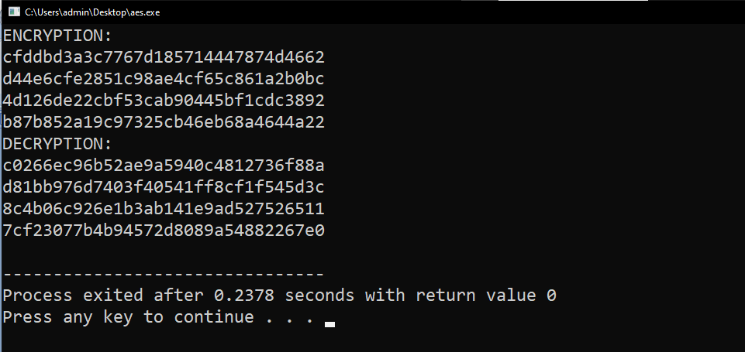

**VIVA VOICE:**

# 1. What is the DES algorithm?

1. Data Encryption Standard (DES) is a block cipher algorithm that takes plain text in blocks of 64 bits and converts them to ciphertext using keys of 48 bits. It is a symmetric key algorithm, which means that the same key is used for encrypting and decrypting ​data.
2. **What exactly is the AES algorithm?**
3. The AES Encryption algorithm (also known as the Rijndael algorithm) is a symmetric block cipher algorithm with a block/chunk size of 128 bits. It converts these individual blocks using keys of 128, 192, and 256 bits. Once it encrypts these blocks, it joins them together to form the ciphertext.

# What are symmetric and asymmetric key systems?

1. Symmetric encryption uses a private key to encrypt and decrypt an encrypted email. Asymmetric encryption uses the public key of the recipient to encrypt the message. Then, if the recipient wants to decrypt the message, the recipient will have to use their private key to decrypt.
2. **What are the types of fields/levels in the encryption process of AES algorithm?**
3. There are three types of AES: 128-bit, 192-bit, and 256-bit. While all three use the same 128-bit blocks, their difference lies in the length of their key. Since AES-256 has the longest key, it offers the most substantial level of encryption.

The structure of AES and to focus particularly on the four steps used in each round of AES: (1) byte substitution, (2) shift rows, (3) mix columns, and (4) add round key.

# How many rounds and bits used in the DES algorithm?

1. DES uses 16 rounds of the Feistel structure, using a different key for each round. DES is a block cipher that operates on data blocks of 64 bits in size.
2. **What is the difference between DES and Triple DES?**
3. 3DES was developed as a more secure alternative because of DES's small key length. 3DES or Triple DES was built upon DES to improve security. In 3DES, the DES algorithm is run three times with three keys; however, it is only considered secure if three separate keys are used.

# What is the type of cipher is used in the AES algorithm for encrypt and decrypt message?

1. The Advanced Encryption Standard (AES) is a symmetric block cipher chosen by the U.S. government to protect classified information. AES is implemented in software and hardware throughout the world to encrypt sensitive data.

**Week - 4 Asymmetric Cryptography**

* 1. **Write a C Program to implement RSA algorithm. AIM:** To write a C Program to implement RSA algorithm. **DESCRIPTION:**

RSA encryption algorithm is a type of public-key encryption algorithm. Asymmetric actually means that it works on two different keys i.e. **Public Key** and **Private Key.** As the name describes that the Public Key is given to everyone and the Private key is kept private.

# Public key encryption algorithm:

RSA is the common public-key algorithm, named after its inventors **Rivest, Shamir, and Adelman (RSA).**Public Key encryption algorithm is also called the Asymmetric algorithm. Asymmetric algorithms are those algorithms in which sender and receiver use different keys for encryption and decryption. Each sender is assigned a pair of keys:

# Public key 2.Private key

The **Public key** is used for encryption, and the **Private Key** is used for decryption. Decryption cannot be done using a public key. The two keys are linked, but the private key cannot be derived from the public key. The public key is well known, but the private key is secret and it is known only to the user who owns the key. It means that everybody can send a message to the user using user's public key. But only the user can decrypt the message using his private key.

The RSA algorithm holds the following features −

* RSA algorithm is a popular exponentiation in a finite field over integers including prime numbers.
* The integers used by this method are sufficiently large making it difficult to solve.
* There are two sets of keys in this algorithm: private key and public key. Encryption Formula

Consider a sender who sends the plain text message to someone whose public key is **(n,e).** To encrypt the

plain text message in the given scenario, use the following syntax −

Ciphertext = Pe mod n

Decryption Formula

The decryption process is very straightforward and includes analytics for calculation in a systematic approach. Considering receiver **C** has the private key **d**, the result modulus will be calculated as –

Plaintext = Cd mod n

# PROGRAM:

#include<stdio.h> #include<math.h>

//to find gcd

int gcd(int a, int h)

{

int temp; while(1)

{

temp = a%h; if(temp==0) return h;

a = h;

h = temp;

}

}

int main()

{

//2 random prime numbers double p = 3;

double q = 7; double n=p*q; double count;

double totient = (p-1)*(q-1);

//public key

//e stands for encrypt double e=2;

//for checking co-prime which satisfies e>1 while(e<totient){

count = gcd(e,totient); if(count==1)

break; else

e++;

}

//private key

//d stands for decrypt double d;

//k can be any arbitrary value double k = 2;

//choosing d such that it satisfies d*e = 1 + k * totient d = (1 + (k*totient))/e;

double msg = 12; double c = pow(msg,e); double m = pow(c,d); c=fmod(c,n);

m=fmod(m,n);

printf("Message data = %lf",msg); printf("\np = %lf",p);

printf("\nq = %lf",q); printf("\nn = pq = %lf",n); printf("\ntotient = %lf",totient); printf("\ne = %lf",e); printf("\nd = %lf",d);

printf("\nEncrypted data = %lf",c); printf("\nOriginal Message Sent = %lf",m);

return 0;

}

**OUTPUT:**

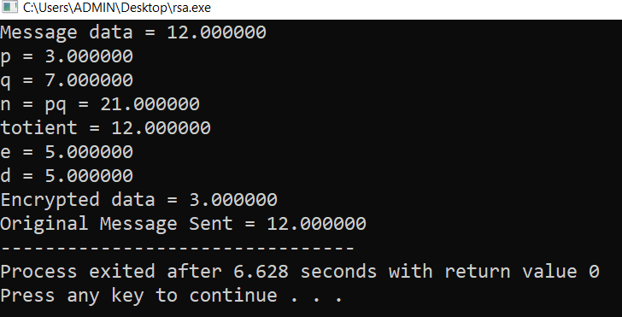

* 1. **Write a C Program to implement Diffie-Helman Key Exchange Algorithm. AIM:** To write a C Program to implement Diffie-Helman Key Exchange Algorithm. **DESCRIPTION:**

The Diffie-Hellman algorithm is being used to establish a shared secret that can be used for

secret communications while exchanging data over a public network using the elliptic curve to generate points and get the secret key using the parameters.

* For the sake of simplicity and practical implementation of the algorithm, we will consider only 4 variables, one prime P and G (a primitive root of P) and two private values a and b.
* P and G are both publicly available numbers. Users (say Alice and Bob) pick private values a and b and they generate a key and exchange it publicly. The opposite person receives the key and that generates a secret key, after which they have the same secret key to encrypt.

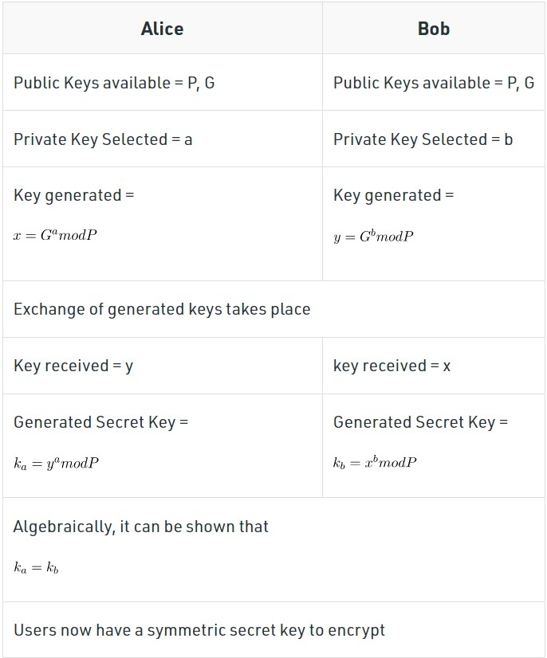

**Vulnerabilities of Diffie-Hellman key exchange**

The most serious limitation of Diffie-Hellman in its basic form is the lack of [authentication.](https://www.techtarget.com/searchsecurity/definition/authentication) Communications using Diffie-Hellman by itself are vulnerable to MitM. Ideally, Diffie-Hellman should be used in conjunction with a recognized authentication method, such as [digital signatures](https://www.techtarget.com/searchsecurity/definition/digital-signature), to verify the identities of the users over the public communications medium.

# PROGRAM:

#include<stdio.h> #include<math.h>

// Power function to return value of a ^ b mod P

long long int power(long long int a, long long int b, long long int P)

{

if (b == 1) return a;

else

return (((long long int)pow(a, b)) % P);

}

//Driver program int main()

{

long long int P, G, x, a, y, b, ka, kb;

// Both the persons will be agreed upon the

// public keys G and P P = 23;

// A prime number P is taken printf("The value of P : %lld\n", P);

G = 9;

// A primitive root for P, G is taken printf("The value of G : %lld\n\n", G);

// Alice will choose the private key a a = 4;

// a is the chosen private key

printf("The private key a for Alice : %lld\n", a); x = power(G, a, P);

// gets the generated key

// Bob will choose the private key b b = 3;

// b is the chosen private key

printf("The private key b for Bob : %lld\n\n", b); y = power(G, b, P);

// gets the generated key

// Generating the secret key after the exchange

// of keys

ka = power(y, a, P); // Secret key for Alice kb = power(x, b, P); // Secret key for Bob

printf("Secret key for the Alice is : %lld\n", ka); printf("Secret Key for the Bob is : %lld\n", kb);

return 0;

}

**OUTPUT:**

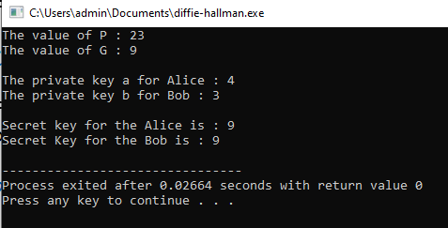

* 1. **Write a C Program to implement Elgamal Cryptographic System. AIM:** To write a C Program to implement Elgamal Cryptographic System.

# DESCRIPTION:

**ElGamal encryption** is a public-key cryptosystem. It uses asymmetric key encryption for communicating between two parties and encrypting the message.

This cryptosystem is based on the difficulty of finding **discrete logarithm** in a cyclic group that is even if we know ga and gk, it is extremely difficult to compute gak.

It can be considered the asymmetric algorithm where the encryption and decryption happen by using public and private keys. In order to encrypt the message, the public key is used by the client, while the message could be decrypted using the private key on the server end.

This is considered an efficient algorithm to perform encryption and decryption as the keys are extremely tough to predict. The sole purpose of introducing the message transaction’s signature is to protect it against MITM, which this algorithm could very effectively achieve.

**Idea of ElGamal cryptosystem**:

- Suppose Alice wants to communicate with Bob.

* + 1. Bob generates public and private keys:
       - Bob chooses a very large number **q** and a cyclic group **F**q.
       - From the cyclic group **F**q, he choose any element **g** and an element **a** such that gcd(a, q) = 1.
       - Then he computes h = ga.
       - Bob publishes **F**, **h = ga**, **q**, and **g** as his public key and retains **a** as private key.
    2. Alice encrypts data using Bob’s public key :
       - Alice selects an element **k** from cyclic group **F**

such that gcd(k, q) = 1.

* + - * Then she computes p = gk and s = hk = gak.
      * She multiples s with M.
      * Then she sends (p, M*s) = (gk, M*s).
    1. Bob decrypts the message :
       - Bob calculates s′ = pa = gak.
       - He divides M*s by s′ to obtain M as s = s′.

It is mainly concerned about the difficulty of leveraging the cyclic group to find the discrete logarithm.

# PROGRAM:

#include <stdio.h> #include <stdlib.h> #include <ctype.h> #include <math.h> int e1, e2;

int p, d;

int C1, C2;

FILE *out1, *out2; int gcd(int a, int b)

{

int q, r1, r2, r; if (a > b)

{

r1 = a; r2 = b;

}

else {

r1 = b; r2 = a;

}

while (r2 > 0)

{

q = r1 / r2;

r = r1 - q * r2; r1 = r2;

r2 = r;

}

return r1;

}

int FastExponention(int bit, int n, int* y, int* a)

{

if (bit == 1) {

*y = (*y * (*a)) % n;

}

*a = (*a) * (*a) % n;

}

int FindT(int a, int m, int n)

{

int r;

int y = 1; while (m > 0)

{

r = m % 2;

FastExponention(r, n, &y, &a); m = m / 2;

}

return y;

}

int PrimarityTest(int a, int i)

{

int n = i - 1; int k = 0; int m, T;

while (n % 2 == 0)

{

k++;

n = n / 2;

}

m = n;

T = FindT(a, m, i);

if (T == 1 || T == i - 1) {

return 1;

}

int j;

for (j = 0; j < k; j++)

{

T = FindT(T, 2, i); if (T == 1) {

return 0;

}

if (T == i - 1) {

return 1;

}

}

return 0;

}

int PrimitiveRoot(int p)

{

int flag; int a;

for (a = 2; a < p; a++)

{

flag = 1; int i;

for (i = 1; i < p; i++)

{

if (FindT(a, i, p) == 1 && i < p - 1) { flag = 0;

}

else if (flag && FindT(a, i, p) == 1 && i == p - 1) { return a;

}

}

}

}

int KeyGeneration()

{

do {

do

p = rand() + 256; while (p % 2 == 0);

} while (!PrimarityTest(2, p)); p = 107;

e1 = 2;

do {

d = rand() % (p - 2) + 1; // 1 <= d <= p-2

} while (gcd(d, p) != 1); d = 67;

e2 = FindT(e1, d, p);

}

int Encryption(int Plaintext)

{

out1 = fopen("cipher1.txt", "a+"); out2 = fopen("cipher2.txt", "a+"); int r;

do {

r = rand() % (p - 1) + 1; // 1 < r < p

}

while (gcd(r, p) != 1); C1 = FindT(e1, r, p);

C2 = FindT(e2, r, p) * Plaintext % p; fprintf(out1, "%d ", C1);

fprintf(out2, "%d ", C2); fclose(out1);

fclose(out2);

}

int Decryption(int C1, int C2)

{

FILE* out = fopen("result.txt", "a+");

int decipher = C2 * FindT(C1, p - 1 - d, p) % p; fprintf(out, "%c", decipher);

fclose(out);

}

int main()

{

FILE *out, *inp;

// destroy contents of these files (from previous runs, if any) out = fopen("result.txt", "w+");

fclose(out);

out = fopen("cipher1.txt", "w+"); fclose(out);

out = fopen("cipher2.txt", "w+"); fclose(out);

KeyGeneration();

inp = fopen("plain.txt", "r+");

if (inp == NULL)

{

printf("Error opening Source File.\n"); exit(1);

}

while (1)

{

char ch = getc(inp); if (ch == EOF) {

break; // M < p

}

Encryption(toascii(ch));

}

fclose(inp);

FILE *inp1, *inp2;

inp1 = fopen("cipher1.txt", "r"); inp2 = fopen("cipher2.txt", "r"); int C1, C2;

while (1)

{

int ret = fscanf(inp1, "%d", &C1);

fscanf(inp2, "%d", &C2); if (ret == -1) {

break;

}

Decryption(C1, C2);

}

fclose(inp1); fclose(inp2); return 0;

}

# OUTPUT:

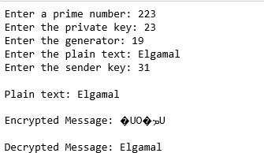

**VIVA VOICE:**

# What is the RSA algorithm?

1. The RSA algorithm is an asymmetric cryptography algorithm; this means that it uses a public key and a private key (i.e two different, mathematically linked keys). As their names suggest, a public key is shared publicly, while a private key is secret and must not be shared with anyone.
2. **What do you know about Diffie-Hellman key exchange algorithm?**
3. The Diffie–Hellman (DH) Algorithm is a key-exchange protocol that enables two parties communicating over public channel to establish a mutual secret without it being transmitted over the Internet. DH enables the two to use a public key to encrypt and decrypt their conversation or data using symmetric cryptography.

# What is Elgamal cryptographic algorithm?

1. **ElGamal encryption**is a public-key cryptosystem. It uses asymmetric key encryption for communicating between two parties and encrypting the message.
2. **What are the types of fields/levels in the encryption process of AES algorithm?**
3. There are three types of AES: 128-bit, 192-bit, and 256-bit. While all three use the same 128-bit blocks, their difference lies in the length of their key. Since AES-256 has the longest key, it offers the most substantial level of encryption.

The structure of AES and to focus particularly on the four steps used in each round of AES: (1) byte substitution, (2) shift rows, (3) mix columns, and (4) add round key.

# How many rounds and bits used in the DES algorithm?

1. DES uses 16 rounds of the Feistel structure, using a different key for each round. DES is a block cipher that operates on data blocks of 64 bits in size.
2. **What is the difference between DES and Triple DES?**
3. 3DES was developed as a more secure alternative because of DES's small key length. 3DES or Triple DES was built upon DES to improve security. In 3DES, the DES algorithm is run three times with three keys; however, it is only considered secure if three separate keys are used.

# What is the type of cipher is used in the AES algorithm for encrypt and decrypt message?

1. The Advanced Encryption Standard (AES) is a symmetric block cipher chosen by the U.S. government to protect classified information. AES is implemented in software and hardware throughout the world to encrypt sensitive data.

**Week - 5 Message Authentication Codes**

* 1. **Write a C Program to implement HMAC AIM:** To write a C Program to implement HMAC. **DESCRIPTION:**

**HMAC** (Hash-based Message Authentication Code) is a type of a message authentication code (MAC) that is acquired by executing a cryptographic hash function on the data (that is) to be authenticated and a secret shared key. Like any of the MAC, it is used for both data integrity and authentication.

Checking data integrity is necessary for the parties involved in communication. HTTPS, SFTP, FTPS, and other transfer protocols use HMAC.

The cryptographic hash function may be MD-5, SHA-1, or SHA-256. Digital signatures are nearly similar to HMACs i.e they both employ a hash function and a shared key. The difference lies in the keys i.e HMACs use symmetric key(same copy) while Signatures use asymmetric (two different keys).

# WORKING Of HMAC:

HMACs provides client and server with a shared private key that is known only to them. The client makes a unique hash (HMAC) for every request. When the client requests the server, it hashes the requested data with a private key and sends it as a part of the request. Both the message and key are hashed in separate steps making it secure. When the server receives the request, it makes its own HMAC. Both the HMACS are compared and if both are equal, the client is considered legitimate.

The formula **for HMAC:**

# HMAC = hashFunc(secret key + message)

There are three types of authentication functions.

* + 1. encryption 2.message authentication code 3.hash functions.

The major difference between MAC and hash (HMAC here) is the dependence of a key. In HMAC we have to apply the hash function along with a key on the plain text. The hash function will be applied to the plain text message.

But before applying, we have to compute S bits and then append it to plain text and after that apply the hash function. For generating those S bits we make use of a key that is shared between the sender and receiver.

# PROGRAM:

#define TRACE_LEVEL CRYPTO_TRACE_LEVEL

//Dependencies #include "core/crypto.h" #include "mac/hmac.h"

//Check crypto library configuration

#if (HMAC_SUPPORT == ENABLED)

//HMAC with MD5 OID (1.3.6.1.5.5.8.1.1)

const uint8_t HMAC_WITH_MD5_OID[8] = {0x2B, 0x06, 0x01, 0x05, 0x05, 0x08, 0x01, 0x01};

//HMAC with Tiger OID (1.3.6.1.5.5.8.1.3)

const uint8_t HMAC_WITH_TIGER_OID[8] = {0x2B, 0x06, 0x01, 0x05, 0x05, 0x08, 0x01, 0x03};

//HMAC with RIPEMD-160 OID (1.3.6.1.5.5.8.1.4)

const uint8_t HMAC_WITH_RIPEMD160_OID[8] = {0x2B, 0x06, 0x01, 0x05, 0x05, 0x08, 0x01, 0x04};

//HMAC with SHA-1 OID (1.2.840.113549.2.7)

const uint8_t HMAC_WITH_SHA1_OID[8] = {0x2A, 0x86, 0x48, 0x86, 0xF7, 0x0D, 0x02, 0x07};

//HMAC with SHA-224 OID (1.2.840.113549.2.8)

const uint8_t HMAC_WITH_SHA224_OID[8] = {0x2A, 0x86, 0x48, 0x86, 0xF7, 0x0D, 0x02, 0x08};

//HMAC with SHA-256 OID (1.2.840.113549.2.9)

const uint8_t HMAC_WITH_SHA256_OID[8] = {0x2A, 0x86, 0x48, 0x86, 0xF7, 0x0D, 0x02, 0x09};

//HMAC with SHA-384 OID (1.2.840.113549.2.10)

const uint8_t HMAC_WITH_SHA384_OID[8] = {0x2A, 0x86, 0x48, 0x86, 0xF7, 0x0D, 0x02, 0x0A};

//HMAC with SHA-512 OID (1.2.840.113549.2.11)

const uint8_t HMAC_WITH_SHA512_OID[8] = {0x2A, 0x86, 0x48, 0x86, 0xF7, 0x0D, 0x02, 0x0B};

//HMAC with SHA-512/224 OID (1.2.840.113549.2.12)

const uint8_t HMAC_WITH_SHA512_224_OID[8] = {0x2A, 0x86, 0x48, 0x86, 0xF7, 0x0D, 0x02, 0x0C};

//HMAC with SHA-512/256 OID (1.2.840.113549.2.13)

const uint8_t HMAC_WITH_SHA512_256_OID[8] = {0x2A, 0x86, 0x48, 0x86, 0xF7, 0x0D, 0x02, 0x0D};

//HMAC with SHA-3-224 object identifier (2.16.840.1.101.3.4.2.13)

const uint8_t HMAC_WITH_SHA3_224_OID[9] = {0x60, 0x86, 0x48, 0x01, 0x65, 0x03, 0x04, 0x02, 0x0D};

//HMAC with SHA-3-256 object identifier (2.16.840.1.101.3.4.2.14)

const uint8_t HMAC_WITH_SHA3_256_OID[9] = {0x60, 0x86, 0x48, 0x01, 0x65, 0x03, 0x04, 0x02, 0x0E};

//HMAC with SHA-3-384 object identifier (2.16.840.1.101.3.4.2.15)

const uint8_t HMAC_WITH_SHA3_384_OID[9] = {0x60, 0x86, 0x48, 0x01, 0x65, 0x03, 0x04, 0x02, 0x0F};

//HMAC with SHA-3-512 object identifier (2.16.840.1.101.3.4.2.16)

const uint8_t HMAC_WITH_SHA3_512_OID[9] = {0x60, 0x86, 0x48, 0x01, 0x65, 0x03, 0x04,

0x02, 0x10};

/**

* @brief Compute HMAC using the specified hash function
* @param[in] hash Hash algorithm used to compute HMAC
* @param[in] key Key to use in the hash algorithm
* @param[in] keyLen Length of the key
* @param[in] data The input data for which to compute the hash code
* @param[in] dataLen Length of the input data
* @param[out] digest The computed HMAC value
* @return Error code

**/

weak_func error_t hmacCompute(const HashAlgo *hash, const void *key, size_t keyLen, const void *data, size_t dataLen, uint8_t *digest)

{

error_t error;

HmacContext *context;

//Allocate a memory buffer to hold the HMAC context context = cryptoAllocMem(sizeof(HmacContext));

//Successful memory allocation? if(context != NULL)

{

//Initialize the HMAC context

error = hmacInit(context, hash, key, keyLen);

//Check status code if(!error)

{

//Digest the message hmacUpdate(context, data, dataLen);

//Finalize the HMAC computation hmacFinal(context, digest);

}

//Free previously allocated memory cryptoFreeMem(context);

}

else

{

//Failed to allocate memory

error = ERROR_OUT_OF_MEMORY;

}

return error;

}

/**

* @brief Initialize HMAC calculation
* @param[in] context Pointer to the HMAC context to initialize
* @param[in] hash Hash algorithm used to compute HMAC
* @param[in] key Key to use in the hash algorithm
* @param[in] keyLen Length of the key
* @return Error code

**/

weak_func error_t hmacInit(HmacContext *context, const HashAlgo *hash, const void *key, size_t keyLen)

{

uint_t i;

//Check parameters

if(context == NULL || hash == NULL)

return ERROR_INVALID_PARAMETER;

//Make sure the supplied key is valid if(key == NULL && keyLen != 0)

return ERROR_INVALID_PARAMETER;

//Hash algorithm used to compute HMAC context->hash = hash;

//The key is longer than the block size? if(keyLen > hash->blockSize)

{

//Initialize the hash function context hash->init(&context->hashContext);

//Digest the original key

hash->update(&context->hashContext, key, keyLen);

//Finalize the message digest computation

hash->final(&context->hashContext, context->key);

//Key is padded to the right with extra zeros osMemset(context->key + hash->digestSize, 0,

hash->blockSize - hash->digestSize);

}

else

{

//Copy the key

osMemcpy(context->key, key, keyLen);

//Key is padded to the right with extra zeros

osMemset(context->key + keyLen, 0, hash->blockSize - keyLen);}

//XOR the resulting key with ipad for(i = 0; i < hash->blockSize; i++)

{

context->key[i] ^= HMAC_IPAD;

}

//Initialize context for the first pass hash->init(&context->hashContext);

//Start with the inner pad

hash->update(&context->hashContext, context->key, hash->blockSize);

//Successful initialization return NO_ERROR;

}

/**

* @brief Update the HMAC context with a portion of the message being hashed
* @param[in] context Pointer to the HMAC context
* @param[in] data Pointer to the buffer being hashed
* @param[in] length Length of the buffer

**/

weak_func void hmacUpdate(HmacContext *context, const void *data, size_t length)

{

const HashAlgo *hash;

//Hash algorithm used to compute HMAC hash = context->hash;

//Digest the message (first pass)

hash->update(&context->hashContext, data, length);

}

/**

* @brief Finish the HMAC calculation
* @param[in] context Pointer to the HMAC context
* @param[out] digest Calculated HMAC value (optional parameter)

**/

weak_func void hmacFinal(HmacContext *context, uint8_t *digest)

{

uint_t i;

const HashAlgo *hash;

//Hash algorithm used to compute HMAC hash = context->hash; //Finish the first pass

hash->final(&context->hashContext, context->digest);

//XOR the original key with opad for(i = 0; i < hash->blockSize; i++)

{

context->key[i] ^= HMAC_IPAD ^ HMAC_OPAD;

}

//Initialize context for the second pass hash->init(&context->hashContext);

//Start with outer pad

hash->update(&context->hashContext, context->key, hash->blockSize);

//Then digest the result of the first hash

hash->update(&context->hashContext, context->digest, hash->digestSize);

//Finish the second pass

hash->final(&context->hashContext, context->digest);

//Copy the resulting HMAC value if(digest != NULL)

{

osMemcpy(digest, context->digest, hash->digestSize);

}

}

/**

* @brief Finish the HMAC calculation (no padding added)
* @param[in] context Pointer to the HMAC context
* @param[out] digest Calculated HMAC value (optional parameter)

**/

void hmacFinalRaw(HmacContext *context, uint8_t *digest)

{

uint_t i;

const HashAlgo *hash;

//Hash algorithm used to compute HMAC hash = context->hash;

//XOR the original key with opad for(i = 0; i < hash->blockSize; i++)

{

context->key[i] ^= HMAC_IPAD ^ HMAC_OPAD;

}

//Initialize context for the second pass hash->init(&context->hashContext);

//Start with outer pad

//Then digest the result of the first hash

hash->update(&context->hashContext, context->digest, hash->digestSize);

//Finish the second pass

hash->final(&context->hashContext, context->digest);

//Copy the resulting HMAC value if(digest != NULL)

{

osMemcpy(digest, context->digest, hash->digestSize);

}

}

# OUTPUT:

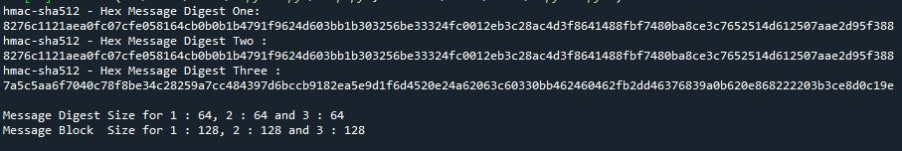

* 1. **Write a C Program to implement CMAC AIM:** To write a C Program to implement CMAC. **DESCRIPTION:**

Cipher-Based Message Authentication Code (CMAC) is a MAC that is based on the use of a block cipher mode of operations for use with AES and tripleDES. It is also adopted by NIST. The CMAC overcomes the limitations of the Data Authentication Algorithm (DAA) which is based on DES.

CMACs (Cipher-based message authentication codes) create message authentication codes (MACs) using a block cipher and a secret key. They differ from HMACs in that they use a block symmetric key method for the MACs rather than a hashing method.

Generally **CMAC will be slower than HMAC**, as hashing methods are generally faster than block cipher methods. In most cases HMAC will work best, but CMAC may work better where there is embedded hardware which has hardware acceleration for block ciphers. For this, CMAC would likely run faster than HMAC.

The operation of the CMAC can be defined as follows: when the message is an integer multiple n of the cipher block length b. For AES, b = 128, and for tripleDES, b = 64. The message is divided into n blocks (M1 , M2 ,…, Mn ). The algorithm makes use of a k-bit encryption key K and a b-bit constant, K1 . For AES, the key size k is 128, 192, or 256 bits; for triple DES, the key size is 112 or 168 bits.

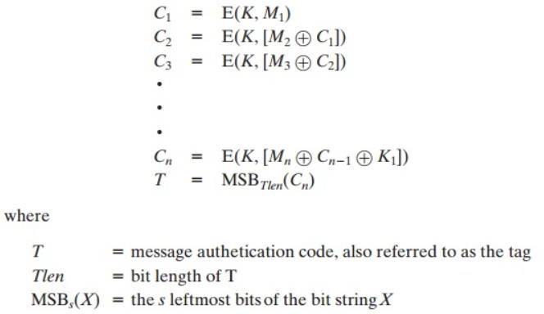

If the message is not an integer multiple of the cipher block length, then the final block is padded to the right (least significant bits) with a 1 and as many 0s as necessary so that the final block is also of length *b*.

The CMAC operation then pro- ceeds as before, except that a different *n*-bit key *K*2 is used instead of *K*1.

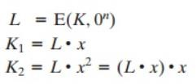

# PROGRAM:

#include "cryptlib.h" #include "secblock.h" #include "osrng.h" #include "files.h" #include "cmac.h" #include "aes.h" #include "hex.h"

using namespace CryptoPP;

#include <iostream> #include <string> using namespace std;

int main(int argc, char* argv[])

{

AutoSeededRandomPool prng;

SecByteBlock key(AES::DEFAULT_KEYLENGTH); prng.GenerateBlock(key, key.size());

string mac, plain = "CMAC Test"; HexEncoder encoder(new FileSink(cout));

// Pretty print key cout << "key: ";

encoder.Put(key, key.size()); encoder.MessageEnd();

cout << endl;

cout << "plain text: ";

encoder.Put((const byte*)plain.data(), plain.size()); encoder.MessageEnd();

cout << endl;

try

{

CMAC<AES> cmac(key.data(), key.size()); cmac.Update((const byte*)plain.data(), plain.size());

mac.resize(cmac.DigestSize()); cmac.Final((byte*)&mac[0]);

}

catch(const CryptoPP::Exception& e)

{

cerr << e.what() << endl; exit(1);}

// Pretty print cout << "cmac: ";

encoder.Put((const byte*)mac.data(), mac.size()); encoder.MessageEnd();

cout << endl;

// Verify try

{

CMAC<AES> cmac(key.data(), key.size()); cmac.Update((const byte*)plain.data(), plain.size());

// Call Verify() instead of Final()

bool verified = cmac.Verify((byte*)&mac[0]); if (!verified)

throw Exception(Exception::DATA_INTEGRITY_CHECK_FAILED, "CMAC: message MAC not valid");

cout << "Verified message MAC" << endl;

}

catch(const CryptoPP::Exception& e)

{

cerr << e.what() << endl; exit(1);

}

return 0;

}

**OUTPUT:**

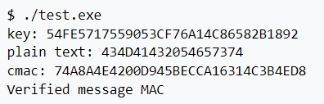

**VIVA VOICE:**

# What is the HMAC algorithm?

1. HMAC is a message authentication code (MAC) using a hash function. It combines with any cryptographic hash function, for example, md5, sha1, sha256. Hash function is wrapped to a class as one template parameter in HMAC and the wrapper class only has a static function involving the hash function.
2. **What are the types of authentication functions in the HMAC?**
3. HMAC uses generic cryptographic hash functions, such as SHA-1, MD5, or RIPEMD-128/60.

# What is the formula for the HMAC?

1. HMAC is a specific type of message authentication code (MAC) involving a cryptographic hash function and a secret cryptographic key.

**The formula for HMAC:**

HMAC = hashFunc(secret key + message)

1. **What is MAC and define the types of MAC?**
2. Message Authentication Code (MAC), also referred to as a tag, is used to authenticate the origin and nature of a message. MACs use authentication cryptography to verify the legitimacy of data sent through a network or transferred from one person to another.

# Define CMAC algorithm?

1. There are four types of MACs: unconditionally secure, hash function-based, stream cipher-based and block cipher-based.
2. **What the limitations of DAA in DES and how CMAC overcome the limitations?**
3. **Limitations** :

* Hardware implementations of DES are very quick.
* DES was not designed for application and therefore it runs relatively slowly.

The CMAC overcomes the limitations of the Data Authentication Algorithm (DAA) which is based on DES.

* CMAC overcomes the limitations of DAA by providing efficient authentication and data integrity protection in a single step, without the need for separate encryption and authentication steps.

**Week - 6 Hash Function**

# 6.1) Write a C Program to implement SHA-512 Algorithm.

**AIM:** To write a C Program to implement SHA-512 Algorithm.

# DESCRIPTION:

SHA-512 is a member of the NIST-standardized SHA-2 family of cryptographic hash functions that produces a 512-bit digest and, therefore, provides 256 bits of security against collisions . The input message can have a length of up to 2 128 − 1 bits and is processed in blocks of 1024 bits.

Like other members of the SHA-2 family, SHA-512 is based on the well-known Merkle-Damgård structure with a Davies-Meyer compression function that uses solely Boolean operations (i.e. bitwise AND, XOR, OR, and NOT), modular additions, as well as shifts and rotations. All operations are applied to 64-bit words.

**SHA-512 consists of two stages:** preprocessing and hash computation**.** In the former stage, the eight working variables, denoted as a, b, c, d, e, f, g, and h in [17], are initialized to certain fixed constants. Furthermore, the input message is padded and then divided into 1024-bit blocks. The actual **hash computation** passes each message block (represented by 16 words m0, m1, . . . m15 of 64 bits each) through a message schedule to expand them to 80 words wi with 0 ≤ i ≤ 79.

Then, the eight working variables are updated using a compression function that consists of 80 rounds. A round of the compression function is exemplarily depicted in Fig. 2. The **processing** of a 1024-bit message block results in eight 64-bit intermediate hash values. After the whole message has been processed, the 512-bit digest is generated by simply concatenating the eight intermediate hash values.

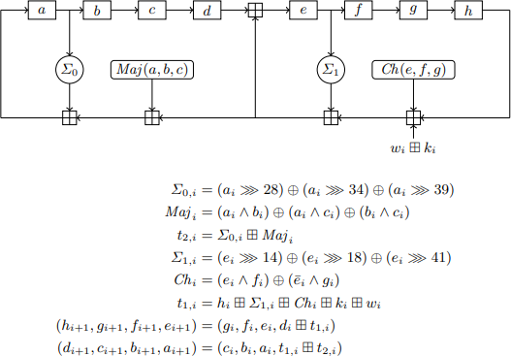

# PROGRAM:

#include <stdlib.h> #include <string.h>

#include "SHA512.h" #include "config.h"

// K: first 64 bits of the fractional parts of the cube roots of the first 80 primes const static uint64_t K[80] =

{

0x428A2F98D728AE22, 0x7137449123EF65CD, 0xB5C0FBCFEC4D3B2F,

0xE9B5DBA58189DBBC,

0x3956C25BF348B538, 0x59F111F1B605D019, 0x923F82A4AF194F9B, 0xAB1C5ED5DA6D8118,

0xD807AA98A3030242, 0x12835B0145706FBE, 0x243185BE4EE4B28C, 0x550C7DC3D5FFB4E2,

0x72BE5D74F27B896F, 0x80DEB1FE3B1696B1, 0x9BDC06A725C71235, 0xC19BF174CF692694,

0xE49B69C19EF14AD2, 0xEFBE4786384F25E3, 0x0FC19DC68B8CD5B5,

0x240CA1CC77AC9C65,

0x2DE92C6F592B0275, 0x4A7484AA6EA6E483, 0x5CB0A9DCBD41FBD4,

0x76F988DA831153B5,

0x983E5152EE66DFAB, 0xA831C66D2DB43210, 0xB00327C898FB213F, 0xBF597FC7BEEF0EE4,

0xC6E00BF33DA88FC2, 0xD5A79147930AA725, 0x06CA6351E003826F, 0x142929670A0E6E70,

0x27B70A8546D22FFC, 0x2E1B21385C26C926, 0x4D2C6DFC5AC42AED, 0x53380D139D95B3DF,

0x650A73548BAF63DE, 0x766A0ABB3C77B2A8, 0x81C2C92E47EDAEE6, 0x92722C851482353B,

0xA2BFE8A14CF10364, 0xA81A664BBC423001, 0xC24B8B70D0F89791, 0xC76C51A30654BE30,

0xD192E819D6EF5218, 0xD69906245565A910, 0xF40E35855771202A, 0x106AA07032BBD1B8,

0x19A4C116B8D2D0C8, 0x1E376C085141AB53, 0x2748774CDF8EEB99, 0x34B0BCB5E19B48A8,

0x391C0CB3C5C95A63, 0x4ED8AA4AE3418ACB, 0x5B9CCA4F7763E373,

0x682E6FF3D6B2B8A3,

0x748F82EE5DEFB2FC, 0x78A5636F43172F60, 0x84C87814A1F0AB72, 0x8CC702081A6439EC,

0x90BEFFFA23631E28, 0xA4506CEBDE82BDE9, 0xBEF9A3F7B2C67915, 0xC67178F2E372532B,

0xCA273ECEEA26619C, 0xD186B8C721C0C207, 0xEADA7DD6CDE0EB1E,

0xF57D4F7FEE6ED178,

0x06F067AA72176FBA, 0x0A637DC5A2C898A6, 0x113F9804BEF90DAE, 0x1B710B35131C471B,

0x28DB77F523047D84, 0x32CAAB7B40C72493, 0x3C9EBE0A15C9BEBC,

0x431D67C49C100D4C,

0x4CC5D4BECB3E42B6, 0x597F299CFC657E2A, 0x5FCB6FAB3AD6FAEC,

0x6C44198C4A475817

};

// Utility functions

// Rotate x to the right by numBits

#define ROTR(x, numBits) ( (x >> numBits) | (x << (64 - numBits)) )

// Compression functions

#define Ch(x,y,z) ( (x & y) ^ ((~x) & z) )

#define Maj(x,y,z) ( (x & y) ^ (x & z) ^ (y & z) )

#define BigSigma0(x) ( ROTR(x,28) ^ ROTR(x,34) ^ ROTR(x,39) )

#define BigSigma1(x) ( ROTR(x,14) ^ ROTR(x,18) ^ ROTR(x,41) )

#define SmallSigma0(x) ( ROTR(x,1) ^ ROTR(x,8) ^ (x >> 7) ) #define SmallSigma1(x) ( ROTR(x,19) ^ ROTR(x,61) ^ (x >> 6) )

// SHA512 message schedule

// Calculate the Nth block of W uint64_t *W(int N, uint64_t *M)

{

uint64_t *w = (uint64_t*) malloc(sizeof(uint64_t) * 80); uint64_t *mPtr = &M[(N * 16)];

//printf("Message block %d : ", N); for (int i = 0; i < 16; ++i)

{

w[i] = *mPtr;

++mPtr;

//printf("%" PRIx64 , w[i]);

}

//printf("\n");

for (int i = 16; i < 80; ++i)

{

w[i] = SmallSigma1(w[i - 2]) + w[i - 7] + SmallSigma0(w[i - 15]) + w[i - 16];

}

return w;

}

// Step 1:

// Preprocesses a given message of l bits.

// Appends "1" to end of msg, then k 0 bits such that l + 1 + k = 896 mod 1024

// and k is the smallest nonnegative solution to said equation. To this is appended

// the 128 bit block equal to the bit length l.

//char *preprocess(char *msg)

PaddedMsg preprocess(uint8_t *msg, size_t len)

{

PaddedMsg padded;

// resulting msg wll be multiple of 1024 bits

//size_t len = strlen(msg);

if (msg == NULL || len == 0)

{

padded.length = 0; padded.msg = NULL; return padded;

}

size_t l = len * 8;

//printf("k = %zu\n", k);

//printf("l = %zu\n", l);

//printf("l + k + 1 = %zu bits, %zu bytes\n", (l+k+1), ((l+k+1)/8));

padded.length = ((l + k + 1) / 8) + 16;

//printf("padded.length = %zu\n", padded.length);

padded.msg = (uint8_t*) malloc(sizeof(uint8_t) * padded.length); memset(&padded.msg[0], 0, padded.length);

for (size_t i = 0; i < len; ++i) padded.msg[i] = msg[i];

// append to the binary string a 1 followed by k zeros padded.msg[len] = 0x80;

// last 16 bytes reserved for length

uint128_t bigL = l; endianSwap128(&bigL);

memcpy(&padded.msg[padded.length - sizeof( uint128_t)], &bigL, sizeof( uint128_t));

return padded;

}

// Step 2: Parse the padded message into N 1024-bit blocks | Each block separated into 64-bit words

// (therefore 16 per block) | Returns an array of 8 64 bit words corresponding to the hashed value uint64_t *getHash(PaddedMsg *p)

{

size_t N = p->length / SHA512_MESSAGE_BLOCK_SIZE;

//printf("Number of blocks = %zu\n", N);

// initial hash value uint64_t h[8] = {

0x6A09E667F3BCC908,

0xBB67AE8584CAA73B,

0x3C6EF372FE94F82B,

0xA54FF53A5F1D36F1,

0x510E527FADE682D1,

0x9B05688C2B3E6C1F,

0x1F83D9ABFB41BD6B,

0x5BE0CD19137E2179

};

#if MACHINE_BYTE_ORDER == LITTLE_ENDIAN

// Convert byte order of message to big endian uint64_t *msg = ((uint64_t*)&p->msg[0]); for (int i = 0; i < N * 16; ++i)

endianSwap64(msg++); #endif

for (size_t i = 0; i < N; ++i)

{

uint64_t T1, T2;

// initialize registers

uint64_t reg[HASH_ARRAY_LEN];

for (int i = 0; i < HASH_ARRAY_LEN; ++i) reg[i] = h[i];

uint64_t *w = W(i, ((uint64_t*)(p->msg))); for (int j = 0; j < 80; ++j)

{

T1 = reg[7] + BigSigma1(reg[4]) + Ch(reg[4], reg[5], reg[6]) + K[j] + w[j];

T2 = BigSigma0(reg[0]) + Maj(reg[0], reg[1], reg[2]);

reg[7] = reg[6];

reg[6] = reg[5];

reg[5] = reg[4]; reg[4] = reg[3] + T1; reg[3] = reg[2];

reg[2] = reg[1];

reg[1] = reg[0]; reg[0] = T1 + T2;

}

for (int i = 0; i < HASH_ARRAY_LEN; ++i) h[i] += reg[i];

free(w);

}

free(p->msg);

uint64_t *retVal = (uint64_t*) malloc(sizeof(uint64_t) * HASH_ARRAY_LEN); memcpy(retVal, h, sizeof(uint64_t) * HASH_ARRAY_LEN);

return retVal;

}

uint64_t *SHA512Hash(uint8_t *input, size_t len)

{

PaddedMsg paddedMsg = preprocess(input, len); return getHash(&paddedMsg);

}

# OUTPUT:

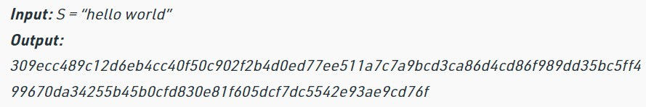

**VIVA VOICE:**

# What is the SHA algorithm?

1. SHA (Secure Hash Algorithm) is a family of cryptographic hash functions used to generate a fixed-size message digest for a given input message. It is commonly used for message authentication, digital signatures, and other security applications.
2. **What are the types of SHA algorithm?**
3. There are different types of SHA algorithm: SHA-1, SHA-224, SHA-256, SHA-384, and SHA-512. Each type has a different block size and produces a different length of hash value, but they all follow the same basic principles of SHA algorithm.

# What mechanism is used in the SHA-512?

1. SHA-512 uses a message expansion function and a set of constant values to process the input message in blocks of 1024 bits, and then compresses the output into a fixed-size message digest of 512 bits. It is a secure cryptographic hash function widely used for digital signatures, password storage, and other security applications.
2. **What is difference between SHA-512 and SHA-256?**
3. The main difference between SHA-512 and SHA-256 is the length of their output hash values, with SHA-512 producing a 512-bit hash and SHA-256 producing a 256-bit hash. SHA-512 also has a larger message block size and requires more processing power than SHA-256.

# Explain the stages in the SHA-512 algorithm?

1. The SHA-512 algorithm consists of the following stages: message padding, initial hash value, message expansion, compression function, and final hash value. The input message is padded to a multiple of 1024 bits, and then processed in blocks using a series of bitwise operations, message expansion, and constant values to produce a fixed-size hash value of 512 bits.

**Week - 7 TCP Server Applications**

# Design TCP iterative Client and server application to reverse the given input sentence.

**AIM:** To design TCP iterative Client and server application to reverse the given input sentence.

# DESCRIPTION:

Here we will see how we can create a system, where we will create one client, and a server, and the client can send one string to the server, and the server will reverse the string, and return back to the client.

Here we will use the **concept of socket programming**. To make the client server connection, we have to create port. The port number is one arbitrary number that can be used by the socket. We have to use the same port for client and the server to establish the connection.

**Socket function:** The protocol argument to the socket function is set to zero except for raw sockets.



**Connect function:** The connect function is used by a TCP client to establish a connection with a TCP server.

# int connect(int sockfd, const struct sockaddr *servaddr, socklen_t addrlen);

**Close function:** The normal UNIX close function is also used to close a socket and terminate a TCP connection.

**Listen function:** The second argument to this function specifies the maximum number of connections that the kernel should queue for this socket.

# int listen(int sockfd, int backlog);

**Accept function:** The cliaddr and addrlen argument are used to ret urn the protocol address of the connected peer processes (client).

**Bzero:** It sets the specified number of bytes to 0(zero) in the destination. We often use this function to initialize a socket address structure to 0(zero).



**Bind function:** The bind function assigns alocal protocol address to a socket.

# int bind(int sockfd, const struct sockaddr *myaddr, s ocklen_t addrlen);

To start the program, start the server program first −

# gcc Server.c –o server

Then start client program −

# gcc Client.c –o server

**PROGRAM:**

**TCP Server:**

#include<string.h> #include<stdio.h> #include<stdlib.h> #include<unistd.h> #include<sys/socket.h> #include<sys/types.h> #define MAXLINE 20

#define SERV_PORT 5777 main(int argc,char *argv) {

int i,j; ssize_t n;

char line[MAXLINE]; char revline[MAXLINE]; int listenfd,connfd,clilen;

struct sockaddr_in servaddr,cliaddr; listenfd=socket(AF_INET,SOCK_STREAM,0); bzero(&servaddr,sizeof(servaddr));

servaddr.sin_family=AF_INET; servaddr.sin_port=htons(SERV_PORT); bind(listenfd,(struct sockaddr*)&servaddr,sizeof(servaddr)); listen(listenfd,1);

for( ; ; ) {

clilen=sizeof(cliaddr);

connfd=accept(listenfd,(struct sockaddr*)&cliaddr,&clilen); printf("connect to client");

while(1) {

if((n=read(connfd,line,MAXLINE))==0) break;

line[n-1]='\0'; j=0;

for(i=n-2;i>=0;i--)

revline[j++]=line[i]; revline[j]='\0'; write(connfd,revline,n);

}

}

}

# OUTPUT:

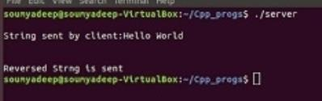

**TCP Client:**

#include<string.h> #include<stdio.h> #include<stdlib.h> #include<unistd.h> #include<sys/socket.h> #include<netinet/in.h> #include<sys/types.h> #define MAXLINE 20

#define SERV_PORT 5777 main(int argc,char *argv)

{

char sendline[MAXLINE],revline[MAXLINE]; int sockfd;

struct sockaddr_in servaddr; sockfd=socket(AF_INET,SOCK_STREAM,0); bzero(&servaddr,sizeof(servaddr)); servaddr.sin_family=AF_INET; servaddr.sin_port=ntohs(SERV_PORT); connect(sockfd,(struct sockaddr*)&servaddr,sizeof(servaddr)); printf("\n enter the data to be send"); while(fgets(sendline,MAXLINE,stdin)!=NULL)

{

}

exit(0);

}

# OUTPUT:

write(sockfd,sendline,strlen(sendline)); printf("\n line send"); read(sockfd,revline,MAXLINE);

printf("\n reverse of the given sentence is : %s",revline); printf("\n");

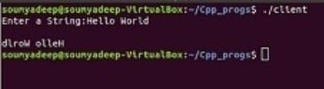

# Design TCP client and server application to transfer file.

**AIM:** To design TCP client and server application to transfer file.

# DESCRIPTION:

If we are creating a connection between client and server using TCP then it has a few functionalities like, TCP is suited for applications that require high reliability, and transmission time is relatively less critical. It is used by other protocols like HTTP, HTTPs, FTP, SMTP, Telnet.

TCP rearranges data packets in the order specified. There is absolute guarantee that the data transferred remains intact and arrives in the same order in which it was sent. TCP does Flow Control and requires three packets to set up a socket connection before any user data can be sent. TCP handles reliability and congestion control. It also does error checking and error recovery. Erroneous packets are retransmitted from the source to the destination.

The entire process can be broken down into the following steps:

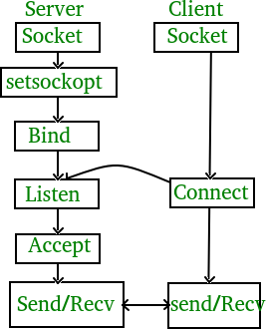

**TCP Server –**

* + 1. using create(), Create TCP socket.
    2. using bind(), Bind the socket to server address.
    3. using listen(), put the server socket in a passive mode, where it waits for the client to approach the server to make a connection
    4. using accept(), At this point, connection is established between client and server, and they are ready to transfer data.
    5. Go back to Step 3.

**TCP Client –**

1. Create TCP socket.
2. connect newly created client socket to server.

**TCP Server:**

#include <stdio.h> #include <netdb.h> #include <netinet/in.h> #include <stdlib.h> #include <string.h> #include <sys/socket.h> #include <sys/types.h>

#include <unistd.h> // read(), write(), close() #define MAX 80

#define PORT 8080 #define SA struct sockaddr

void func(int connfd) // Function designed for chat between client and server.

{

char buff[MAX]; int n;

// infinite loop for chat for (;;) {

bzero(buff, MAX);

read(connfd, buff, sizeof(buff)); // read the message from client and copy it in buffer printf("From client: %s\t To client : ", buff);

bzero(buff, MAX); n = 0;

while ((buff[n++] = getchar()) != '\n') // copy server message in the buffer write(connfd, buff, sizeof(buff)); // and send that buffer to client

// if msg contains "Exit" then server exit and chat ended. if (strncmp("exit", buff, 4) == 0) {

printf("Server Exit...\n"); break;

}

}

}

// Driver function int main()

{

int sockfd, connfd, len;

struct sockaddr_in servaddr, cli;

// socket create and verification

sockfd = socket(AF_INET, SOCK_STREAM, 0); if (sockfd == -1) {

printf("socket creation failed...\n"); exit(0);

}

printf("Socket successfully created..\n"); bzero(&servaddr, sizeof(servaddr));

// assign IP, PORT servaddr.sin_family = AF_INET;

servaddr.sin_addr.s_addr = htonl(INADDR_ANY); servaddr.sin_port = htons(PORT);

// Binding newly created socket to given IP and verification if ((bind(sockfd, (SA*)&servaddr, sizeof(servaddr))) != 0) {

printf("socket bind failed...\n"); exit(0);

}

else

printf("Socket successfully binded..\n");

// Now server is ready to listen and verification if ((listen(sockfd, 5)) != 0) {

printf("Listen failed...\n"); exit(0);

}

else

printf("Server listening..\n");

len = sizeof(cli);

// Accept the data packet from client and verification connfd = accept(sockfd, (SA*)&cli, &len);

if (connfd < 0) {

printf("server accept failed...\n"); exit(0);

}

else

printf("server accept the client...\n");

func(connfd); // Function for chatting between client and server close(sockfd);

}

# OUTPUT:

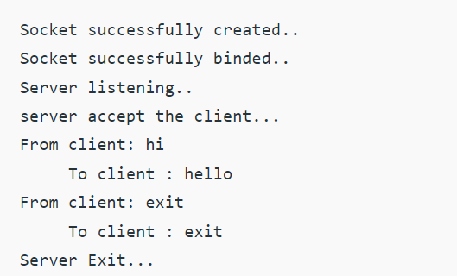

**TCP Client:**

#include <arpa/inet.h> // inet_addr() #include <netdb.h>

#include <stdio.h> #include <stdlib.h> #include <string.h>

#include <strings.h> // bzero() #include <sys/socket.h>

#include <unistd.h> // read(), write(), close() #define MAX 80

#define PORT 8080 #define SA struct sockaddr void func(int sockfd)

{

char buff[MAX]; int n;

for (;;) {

bzero(buff, sizeof(buff)); printf("Enter the string : "); n = 0;

while ((buff[n++] = getchar()) != '\n')

;

write(sockfd, buff, sizeof(buff)); bzero(buff, sizeof(buff)); read(sockfd, buff, sizeof(buff)); printf("From Server : %s", buff);

if ((strncmp(buff, "exit", 4)) == 0) {

printf("Client Exit...\n");

break;

}

}

}

int main()

{

int sockfd, connfd;

struct sockaddr_in servaddr, cli;

// socket create and verification

sockfd = socket(AF_INET, SOCK_STREAM, 0); if (sockfd == -1) {

printf("socket creation failed...\n"); exit(0);

}

else

printf("Socket successfully created..\n");

bzero(&servaddr, sizeof(servaddr));

// assign IP, PORT servaddr.sin_family = AF_INET;

servaddr.sin_addr.s_addr = inet_addr("127.0.0.1"); servaddr.sin_port = htons(PORT);

// connect the client socket to server socket

if (connect(sockfd, (SA*)&servaddr, sizeof(servaddr))

!= 0) {

printf("connection with the server failed...\n"); exit(0);

}

else

printf("connected to the server..\n");

// function for chat func(sockfd);

// close the socket close(sockfd);

}

# OUTPUT:

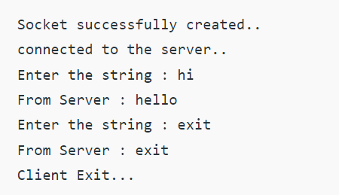

**VIVA VOICE:**

# What is the TCP?

1. TCP (Transport Control Protocol) is a communication protocol in computer networks that provides reliable and ordered delivery of data packets between applications. It is not directly related to cryptography but is often used in conjunction with secure protocols such as SSL/TLS for secure data transmission.
2. **What is client and what is server systems?**
3. Client system is a device or program that requests services or resources from a server system, which is a device or program that provides services or resources to clients. Clients and servers communicate with each other using various protocols, such as HTTP, FTP, or SMTP, to exchange data and perform operations over a network.

# How to connect the client and server?

1. To connect a client and server, the client must first establish a network connection to the server using the appropriate protocol and network address. The server then responds to the client's request, and the two systems exchange data and commands over the established connection until the session is terminated or closed.
2. **What is the networking?**
3. Networking refers to the practice of connecting computing devices and systems together to share resources, exchange data, and communicate with each other over a network. Networking involves the use of various hardware and software components, such as routers, switches, cables, and protocols, to establish and manage network connections.

# Explain connect, bind, listen statements?

1. **connect()** is used by a client to establish a connection to a server. It takes the server address and port number as input parameters and returns a socket descriptor that can be used for data transfer.

**bind()** is used by a server to associate a specific network address and port number with a socket. It takes the address and port as input parameters and returns a socket descriptor that can be used for incoming client connections.

**listen()** is used by a server to wait for incoming client connections on a specific socket. It takes the maximum number of pending connections as input parameter and returns a status code indicating if the operation was successful or not.

**Week - 8 TCP Concurrent Server Applications**

# Design a TCP concurrent server to convert a given text into upper case using multiplexing system call “select”.

**AIM:** To design a TCP concurrent server to convert a given text into upper case using multiplexing system call “select”.

# DESCRIPTION:

When the TCP client is handling two inputs at the same time: standard input and a TCP socket, we encountered a problem when the client was blocked in a call to fgets (on standard input) and the server process was killed. The server TCP correctly sent a FIN to the client TCP, but since the client process was blocked reading from standard input, it never saw the EOF until it read from the socket (possibly much later).

The **Select** function is used to select between TCP and UDP sockets. This function gives instructions to the kernel to wait for any of the multiple events to occur and awakens the process only after one or more events occur or a specified time passes.

**TCP Client:**

* + 1. Create a TCP socket.
    2. Call connect to establish a connection with the server.
    3. When the connection is accepted write a message to a server.
    4. Read the response of the Server.
    5. Close socket descriptor and exit.

# select Function

The select function allows the process to instruct the kernel to either:

* Wait for any one of multiple events to occur and to wake up the process only when one or more of these events occurs, or
* When a specified amount of time has passed.

This means that we tell the kernel what descriptors we are interested in (for reading, writing, or an exception condition) and how long to wait. The descriptors in which we are interested are not restricted to sockets; any descriptor can be tested using select.

Any of the middle three arguments to **select, *readset*, *writeset*, or *exceptset*,** can be specified as a null pointer if we are not interested in that condition. Indeed, if all three pointers are null, then we have a higher precision timer than the normal Unix sleep function. The poll function provides similar functionality.

# Return value of select:

The return value from this function indicates the total number of bits that are ready across all the descriptor sets. If the timer value expires before any of the descriptors are ready, a value of 0 is returned. A return value of –1 indicates an error (which can happen, for example, if the function is interrupted by a caught signal).

# PROGRAM:

**TCP Server:** #include <arpa/inet.h> #include <errno.h>

#include <netinet/in.h> #include <signal.h> #include <stdio.h> #include <stdlib.h> #include <strings.h> #include <sys/socket.h> #include <sys/types.h> #include <unistd.h> #define PORT 5000

#define MAXLINE 1024 int max(int x, int y)

{

if (x > y)

return x;

else

}

return y;

int main()

{

int listenfd, connfd, udpfd, nready, maxfdp1; char buffer[MAXLINE];

pid_t childpid; fd_set rset; ssize_t n;

socklen_t len; const int on = 1;

struct sockaddr_in cliaddr, servaddr; char* message = "Hello Client"; void sig_chld(int);

/* create listening TCP socket */

listenfd = socket(AF_INET, SOCK_STREAM, 0); bzero(&servaddr, sizeof(servaddr)); servaddr.sin_family = AF_INET; servaddr.sin_addr.s_addr = htonl(INADDR_ANY); servaddr.sin_port = htons(PORT);

// binding server addr structure to listenfd

bind(listenfd, (struct sockaddr*)&servaddr, sizeof(servaddr)); listen(listenfd, 10);

/* create UDP socket */

udpfd = socket(AF_INET, SOCK_DGRAM, 0);

// binding server addr structure to udp sockfd

bind(udpfd, (struct sockaddr*)&servaddr, sizeof(servaddr));

// clear the descriptor set FD_ZERO(&rset);

// get maxfd

maxfdp1 = max(listenfd, udpfd) + 1; for (;;) {

// set listenfd and udpfd in readset

FD_SET(listenfd, &rset); FD_SET(udpfd, &rset);

// select the ready descriptor

nready = select(maxfdp1, &rset, NULL, NULL, NULL);

// if tcp socket is readable then handle

// it by accepting the connection if (FD_ISSET(listenfd, &rset)) {

len = sizeof(cliaddr);

connfd = accept(listenfd, (struct sockaddr*)&cliaddr, &len); if ((childpid = fork()) == 0) {

close(listenfd);

bzero(buffer, sizeof(buffer)); printf("Message From TCP client: "); read(connfd, buffer, sizeof(buffer)); puts(buffer);

write(connfd, (const char*)message, sizeof(buffer)); close(connfd);

exit(0);

}

close(connfd);

}

// if udp socket is readable receive the message. if (FD_ISSET(udpfd, &rset)) {

len = sizeof(cliaddr); bzero(buffer, sizeof(buffer));

printf("\nMessage from UDP client: ");

n = recvfrom(udpfd, buffer, sizeof(buffer), 0, (struct sockaddr*)&cliaddr, &len); puts(buffer);

sendto(udpfd, (const char*)message, sizeof(buffer), 0, (struct sockaddr*)&cliaddr, sizeof(cliaddr));

}

}

}

**TCP Client:**

#include <netinet/in.h> #include <stdio.h> #include <stdlib.h> #include <string.h> #include <sys/socket.h> #include <sys/types.h> #define PORT 5000

#define MAXLINE 1024 int main()

{

int sockfd;

char buffer[MAXLINE];

char* message = "Hello Server"; struct sockaddr_in servaddr;

int n, len;

// Creating socket file descriptor

if ((sockfd = socket(AF_INET, SOCK_STREAM, 0)) < 0) { printf("socket creation failed");

exit(0);

}

memset(&servaddr, 0, sizeof(servaddr));

// Filling server information

servaddr.sin_family = AF_INET; servaddr.sin_port = htons(PORT); servaddr.sin_addr.s_addr = inet_addr("127.0.0.1");

if (connect(sockfd, (struct sockaddr*)&servaddr, sizeof(servaddr)) < 0) { printf("\n Error : Connect Failed \n");

}

memset(buffer, 0, sizeof(buffer)); strcpy(buffer, "Hello Server"); write(sockfd, buffer, sizeof(buffer)); printf("Message from server: "); read(sockfd, buffer, sizeof(buffer)); puts(buffer);

close(sockfd);

}

# OUTPUT:

**Server:**

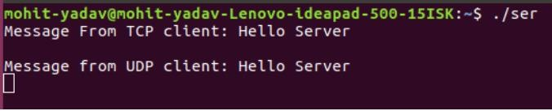

# TCP Client:

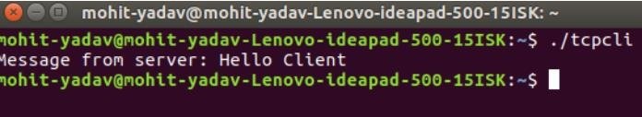

* 1. **Design a TCP concurrent server to echo given set of sentences using poll functions. AIM:** To design a TCP concurrent server to echo given set of sentences using poll functions. **DESCRIPTION:**

When the TCP client is handling two inputs at the same time: standard input and a TCP socket, we encountered a problem when the client was blocked in a call to fgets (on standard input) and the server process was killed. The server TCP correctly sent a FIN to the client TCP, but since the client process was blocked reading from standard input, it never saw the EOF until it read from the socket (possibly much later).

We want to be notified if one or more I/O conditions are ready (i.e., input is ready to be read, or the descriptor is capable of taking more output). This capability is called **I/O multiplexing** and is provided by

the **select and poll functions**, as well as a newer POSIX variation of the former, called **pselect.**

**pselect Function:** The pselect function was invented by POSIX and is now supported by many of the Unix variants.

**poll Function:** poll provides functionality that is similar to select, but poll provides additional information when dealing with STREAMS devices.

**Arguments:** The first argument (*fdarray*) is a pointer to the first element of an array of structures. Each element is a pollfd structure that specifies the conditions to be tested for a given descriptor, fd.

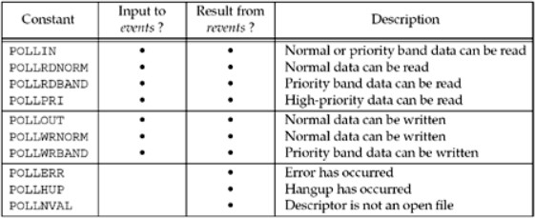

# Return values from poll:

* –1 if an error occurred
* 0 if no descriptors are ready before the timer expires
* Otherwise, it is the number of descriptors that have a nonzero revents member.

# PROGRAM:

#include <stdio.h> #include <stdlib.h> #include <sys/ioctl.h> #include <sys/poll.h> #include <sys/socket.h> #include <sys/time.h> #include <netinet/in.h> #include <errno.h>

#define SERVER_PORT 12345

#define TRUE 1

#define FALSE 0

main (int argc, char *argv[])

{

int len, rc, on = 1;

int listen_sd = -1, new_sd = -1;

int desc_ready, end_server = FALSE, compress_array = FALSE; int close_conn;

char buffer[80];

struct sockaddr_in6 addr; int timeout;

struct pollfd fds[200];

int nfds = 1, current_size = 0, i, j;

listen_sd = socket(AF_INET6, SOCK_STREAM, 0); if (listen_sd < 0)

{

perror("socket() failed"); exit(-1);

}

rc = setsockopt(listen_sd, SOL_SOCKET, SO_REUSEADDR, (char *)&on, sizeof(on));

if (rc < 0)

{

perror("setsockopt() failed"); close(listen_sd);

exit(-1);

}

rc = ioctl(listen_sd, FIONBIO, (char *)&on); if (rc < 0)

{

perror("ioctl() failed"); close(listen_sd);

exit(-1);

}

memset(&addr, 0, sizeof(addr)); addr.sin6_family = AF_INET6;

memcpy(&addr.sin6_addr, &in6addr_any, sizeof(in6addr_any)); addr.sin6_port = htons(SERVER_PORT);

rc = bind(listen_sd,

(struct sockaddr *)&addr, sizeof(addr)); if (rc < 0)

{

perror("bind() failed");

close(listen_sd); exit(-1);

}

rc = listen(listen_sd, 32); if (rc < 0)

{

perror("listen() failed"); close(listen_sd);

exit(-1);

}

memset(fds, 0 , sizeof(fds)); fds[0].fd = listen_sd; fds[0].events = POLLIN; timeout = (3 * 60 * 1000); do

{

printf("Waiting on poll()...\n"); rc = poll(fds, nfds, timeout);

if (rc < 0)

{

perror(" poll() failed"); break;

}

if (rc == 0)

{

printf(" poll() timed out. End program.\n"); break;

}

current_size = nfds;

for (i = 0; i < current_size; i++)

{

if(fds[i].revents == 0) continue;

if(fds[i].revents != POLLIN)

{

printf(" Error! revents = %d\n", fds[i].revents); end_server = TRUE;

break;

}

if (fds[i].fd == listen_sd)

{

printf(" Listening socket is readable\n"); do

{

new_sd = accept(listen_sd, NULL, NULL); if (new_sd < 0)

{

if (errno != EWOULDBLOCK)

{

perror(" accept() failed"); end_server = TRUE;

}

break;

}

printf(" New incoming connection - %d\n", new_sd); fds[nfds].fd = new_sd;

fds[nfds].events = POLLIN; nfds++;

} while (new_sd != -1);

}

else

{

printf(" Descriptor %d is readable\n", fds[i].fd); close_conn = FALSE;

do

{

rc = recv(fds[i].fd, buffer, sizeof(buffer), 0); if (rc < 0)

{

if (errno != EWOULDBLOCK)

{

perror(" recv() failed"); close_conn = TRUE;

}

break;

}

if (rc == 0)

{

printf(" Connection closed\n"); close_conn = TRUE;

break;

}

len = rc;

printf(" %d bytes received\n", len);

rc = send(fds[i].fd, buffer, len, 0); if (rc < 0)

{

perror(" send() failed"); close_conn = TRUE; break;

}

} while(TRUE); if (close_conn)

{

close(fds[i].fd);

fds[i].fd = -1; compress_array = TRUE;

}

} /* End of existing connection is readable */

} /* End of loop through pollable descriptors */ if (compress_array)

{

compress_array = FALSE; for (i = 0; i < nfds; i++)

{

if (fds[i].fd == -1)

{

for(j = i; j < nfds; j++)

{

fds[j].fd = fds[j+1].fd;

}

i--;

nfds--;

}

}

}

} while (end_server == FALSE); /* End of serving running. */ for (i = 0; i < nfds; i++)

{

if(fds[i].fd >= 0)

close(fds[i].fd);

}

}

# OUTPUT:

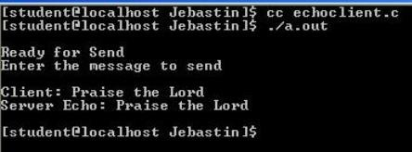

**VIVA VOICE:**

# What is the TCP concurrent server?

1. A TCP concurrent server is a type of server that is capable of handling multiple client connections simultaneously. It does so by creating a new process or thread for each incoming client connection, allowing the server to process multiple requests concurrently without blocking other clients.
   * 1. **What are the TCP concurrent server applications?**
2. CP concurrent servers have a wide range of applications, including:

* Web servers: handling multiple HTTP requests from clients simultaneously.
* Chat servers: allowing multiple clients to chat with each other in real-time.
* Online gaming servers: enabling players to join and play games together over the network.
* File transfer servers: allowing clients to transfer files to and from the server concurrently.
* Remote access servers: enabling multiple users to remotely access and control a server or computer simultaneously.

# What is multiplexing?

1. Multiplexing is the technique of sharing a single communication channel or resource among multiple clients or applications by dividing the available bandwidth into multiple virtual channels.
   * 1. **Explain the “Select” function?**
2. The "select" function is a system call used in computer networking to monitor multiple sockets for data availability, without blocking the execution of the program.

# Explain the “poll” function?

1. The "poll" function is a system call used in computer networking to monitor multiple file descriptors for events, such as data availability or errors, without blocking the execution of the program.
   * 1. **What are the return values of the poll function?**
2. The "poll" function returns a list of structures containing information about the file descriptors that have events pending, such as whether data is available for reading or writing, or if an error occurred. The return value of "poll" is the number of file descriptors with events pending, or -1 if an error occurred.

**Week – 9 UDP Applications**

* 1. **Design UDP Client and server application to reverse the given input sentence. AIM:** To design UDP Client and server application to reverse the given input sentence. **DESCRIPTION:**

In UDP, the client does not form a connection with the server like in TCP and instead sends a datagram. Similarly, the server need not accept a connection and just waits for datagrams to arrive. Datagrams upon arrival contain the address of the sender which the server uses to send data to the correct client.

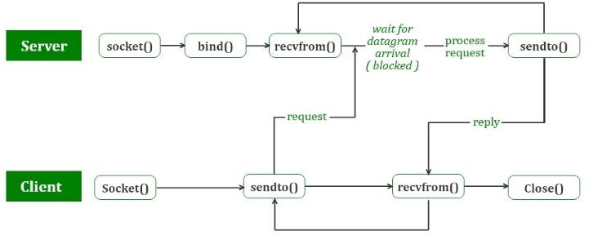

The entire process can be broken down into the following steps :

# UDP Server :

* + 1. Create a UDP socket.
    2. Bind the socket to the server address.
    3. Wait until the datagram packet arrives from the client.
    4. Process the datagram packet and send a reply to the client.
    5. Go back to Step 3.

# UDP Client :

1. Create a UDP socket.
2. Send a message to the server.
3. Wait until a response from the server is received.
4. Process the reply and go back to step 2, if necessary.
5. Close socket descriptor and exit.

# Advantages of using UDP

* Faster than TCP
* Does not restrict you to connection based communication model

# PROGRAM:

**UDP Client:**

#include <sys/socket.h> #include <netdb.h> #include <string.h> #include <stdlib.h> #include <netinet/in.h> #include <arpa/inet.h> #include <unistd.h> #include <stdio.h> #include <string.h>

#define S_PORT 43454

#define C_PORT 43455

#define ERROR -1

#define IP_STR "127.0.0.1"

int main(int argc, char const *argv[]) { int sfd, len;

char str_buf[2048];

struct sockaddr_in servaddr, clientaddr; socklen_t addrlen;

sfd = socket(AF_INET, SOCK_DGRAM,IPPROTO_UDP);

if (sfd == ERROR) {

perror("Could not open a socket"); return 1;

}

memset((char *) &servaddr, 0, sizeof(servaddr));

servaddr.sin_family=AF_INET; servaddr.sin_addr.s_addr=inet_addr(IP_STR); servaddr.sin_port=htons(S_PORT);

memset((char *) &clientaddr, 0, sizeof(clientaddr)); clientaddr.sin_family=AF_INET; clientaddr.sin_addr.s_addr=inet_addr(IP_STR); clientaddr.sin_port=htons(C_PORT);

if((bind(sfd,(struct sockaddr *)&clientaddr,sizeof(clientaddr)))!=0) { perror("Could not bind socket");

return 2;

}

printf("Client is running on %s:%d\n", IP_STR, C_PORT); printf("Enter a string: ");

scanf("%[^\n]%*c",str_buf); len = strlen(str_buf);

sendto(sfd, &len, sizeof(len), 0, (struct sockaddr *)&servaddr, sizeof(servaddr)); sendto(sfd, str_buf, len, 0, (struct sockaddr *)&servaddr, sizeof(servaddr)); addrlen = sizeof(clientaddr);

recvfrom(sfd, &len, sizeof(len), 0, (struct sockaddr *)&clientaddr, &addrlen); recvfrom(sfd, str_buf, len, 0, (struct sockaddr *)&clientaddr, &addrlen); printf("Server Replied: %s\n", str_buf);

return 0;

}

**UDP Server:**

#include <sys/socket.h> #include <netinet/in.h> #include <arpa/inet.h> #include <netdb.h> #include <string.h> #include <stdlib.h> #include <unistd.h> #include <stdio.h>

#define S_PORT 43454

#define C_PORT 43455

#define ERROR -1

#define IP_STR "127.0.0.1"

void strrev(char *str, int len) { int i, j;

char temp;

for (i = 0, j = len -1; i < j; ++i, --j) { temp = str[i];

str[i] = str[j]; str[j] = temp;

}

}

int main(int argc, char const *argv[]) { int sfd, len;

char *str_buf;

struct sockaddr_in servaddr, clientaddr;

sfd = socket(AF_INET, SOCK_DGRAM,IPPROTO_UDP);

if (sfd == ERROR) {

perror("Could not open a socket"); return 1;

}

memset((char *) &servaddr, 0, sizeof(servaddr)); servaddr.sin_family=AF_INET; servaddr.sin_addr.s_addr=htonl(INADDR_ANY); servaddr.sin_port=htons(S_PORT);

memset((char *) &clientaddr, 0, sizeof(clientaddr)); clientaddr.sin_family=AF_INET; clientaddr.sin_addr.s_addr=inet_addr(IP_STR); clientaddr.sin_port=htons(C_PORT);

if((bind(sfd,(struct sockaddr *)&servaddr,sizeof(servaddr)))!=0) { perror("Could not bind socket");

return 2;

}

printf("Server is running on %s:%d\n", IP_STR, S_PORT); while(1) {

recvfrom(sfd, &len, sizeof(len), 0, (struct sockaddr *)&clientaddr, (socklen_t *)&clientaddr); str_buf = (char *) malloc(len*sizeof(char));

recvfrom(sfd, str_buf, len, 0, (struct sockaddr *)&clientaddr, (socklen_t *)&clientaddr);

printf("Client at %s:%d said: %s\t", inet_ntoa(clientaddr.sin_addr), ntohs(clientaddr.sin_port),

str_buf);

strrev(str_buf,len);

sendto(sfd, &len, sizeof(len), 0, (struct sockaddr *)&clientaddr, sizeof(clientaddr));

sendto(sfd, str_buf, len, 0, (struct sockaddr *)&clientaddr, sizeof(clientaddr)); printf("The reverse is: %s\n", str_buf);

free(str_buf);

}

return 0;

}

# OUTPUT:

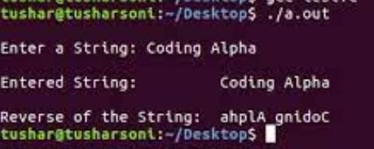

* 1. **Design UDP Client server to transfer a file. AIM:** To design UDP Client server to transfer a file. **DESCRIPTION:**

The UDP or User Datagram Protocol, a communication protocol used for transferring data across the network. It is an unreliable and connectionless communication protocol as it does not establish a proper connection between the client and the server. It is used for time-sensitive applications like gaming, playing videos, or Domain Name System (DNS) lookups. UDP is a faster communication protocol as compared to the TCP

Some of the features of UDP are:

* It’s a connectionless communication protocol.
* It is much faster in comparison with TCP.

In UDP, the client does not form a connection with the server like in TCP and instead sends a datagram. Similarly, the server need not accept a connection and just waits for datagrams to arrive. Datagrams upon arrival contain the address of the sender which the server uses to send data to the correct client.

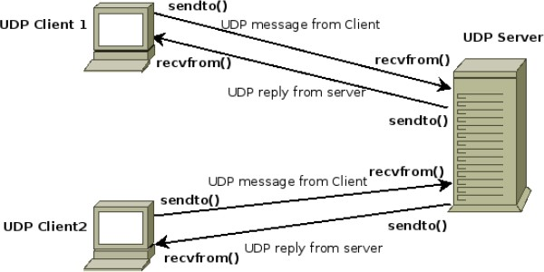

**Algorithm :**

* + 1. The server starts and waits for filename.
    2. The client sends a filename**.**
    3. The server receives filename. If file is present,

server starts reading file

and continues to send a buffer filled with

file contents encrypted until file-end is reached.

* + 1. End is marked by EOF.
    2. File is received as buffers until EOF is received. Then it is decrypted.
    3. If Not present, a file not found is sent.

# PROGRAM:

**Server Implementation:** #include <arpa/inet.h> #include <netinet/in.h> #include <stdio.h> #include <stdlib.h> #include <string.h> #include <sys/socket.h> #include <sys/types.h> #include <unistd.h>

#define IP_PROTOCOL 0

#define PORT_NO 15050

#define NET_BUF_SIZE 32 #define cipherKey 'S' #define sendrecvflag 0

#define nofile "File Not Found!"

// function to clear buffer void clearBuf(char* b)

{

int i;

for (i = 0; i < NET_BUF_SIZE; i++) b[i] = '\0';

}

// function to encrypt

char Cipher(char ch)

{

return ch ^ cipherKey;

}

// function sending file

int sendFile(FILE* fp, char* buf, int s)

{

int i, len;

if (fp == NULL) {

strcpy(buf, nofile); len = strlen(nofile); buf[len] = EOF;

for (i = 0; i <= len; i++)

buf[i] = Cipher(buf[i]); return 1;

}

char ch, ch2;

for (i = 0; i < s; i++) {

ch = fgetc(fp); ch2 = Cipher(ch); buf[i] = ch2;

if (ch == EOF)

return 1;

}

return 0;

}

// driver code int main()

{

int sockfd, nBytes;

struct sockaddr_in addr_con; int addrlen = sizeof(addr_con);

addr_con.sin_family = AF_INET; addr_con.sin_port = htons(PORT_NO); addr_con.sin_addr.s_addr = INADDR_ANY; char net_buf[NET_BUF_SIZE];

FILE* fp;

// socket()

sockfd = socket(AF_INET, SOCK_DGRAM, IP_PROTOCOL);

if (sockfd < 0)

printf("\nfile descriptor not received!!\n");

else

printf("\nfile descriptor %d received\n", sockfd);

// bind()

if (bind(sockfd, (struct sockaddr*)&addr_con, sizeof(addr_con)) == 0) printf("\nSuccessfully binded!\n");

else

printf("\nBinding Failed!\n");

while (1) {

printf("\nWaiting for file name...\n");

// receive file name clearBuf(net_buf);

nBytes = recvfrom(sockfd, net_buf,

NET_BUF_SIZE, sendrecvflag,

(struct sockaddr*)&addr_con, &addrlen);

fp = fopen(net_buf, "r");

printf("\nFile Name Received: %s\n", net_buf); if (fp == NULL)

printf("\nFile open failed!\n");

else

printf("\nFile Successfully opened!\n");

while (1) {

// process

if (sendFile(fp, net_buf, NET_BUF_SIZE)) { sendto(sockfd, net_buf, NET_BUF_SIZE,

sendrecvflag,

(struct sockaddr*)&addr_con, addrlen);

break;

}

// send

sendto(sockfd, net_buf, NET_BUF_SIZE,

sendrecvflag,

(struct sockaddr*)&addr_con, addrlen); clearBuf(net_buf);

}

if (fp != NULL)

fclose(fp);

}

return 0;

}

**Client Implementation:**

// client code for UDP socket programming #include <arpa/inet.h>

#include <netinet/in.h> #include <stdio.h> #include <stdlib.h> #include <string.h> #include <sys/socket.h> #include <sys/types.h> #include <unistd.h>

#define IP_PROTOCOL 0

#define IP_ADDRESS "127.0.0.1" // localhost #define PORT_NO 15050

#define NET_BUF_SIZE 32 #define cipherKey 'S' #define sendrecvflag 0

// function to clear buffer

void clearBuf(char* b)

{

int i;

for (i = 0; i < NET_BUF_SIZE; i++) b[i] = '\0';

}

char Cipher(char ch)

{

return ch ^ cipherKey;

}

int recvFile(char* buf, int s)

{

int i; char ch;

for (i = 0; i < s; i++) {

ch = buf[i];

ch = Cipher(ch); if (ch == EOF)

return 1;

else

}

printf("%c", ch);

return 0;

}

int main()

{

int sockfd, nBytes;

struct sockaddr_in addr_con;

int addrlen = sizeof(addr_con); addr_con.sin_family = AF_INET; addr_con.sin_port = htons(PORT_NO);

addr_con.sin_addr.s_addr = inet_addr(IP_ADDRESS); char net_buf[NET_BUF_SIZE];

FILE* fp;

sockfd = socket(AF_INET, SOCK_DGRAM,

IP_PROTOCOL);

if (sockfd < 0)

printf("\nfile descriptor not received!!\n");

else

printf("\nfile descriptor %d received\n", sockfd);

while (1) {

printf("\nPlease enter file name to receive:\n"); scanf("%s", net_buf);

sendto(sockfd, net_buf, NET_BUF_SIZE, sendrecvflag, (struct sockaddr*)&addr_con, addrlen); printf("\n---------Data Received \n");

while (1) {

clearBuf(net_buf);

nBytes = recvfrom(sockfd, net_buf, NET_BUF_SIZE,sendrecvflag, (struct sockaddr*) &addr_con,&addrlen);

if (recvFile(net_buf, NET_BUF_SIZE)) { break;

}

}

printf("\n \n");

}

return 0;

}

# OUTPUT:

**Server Side:**

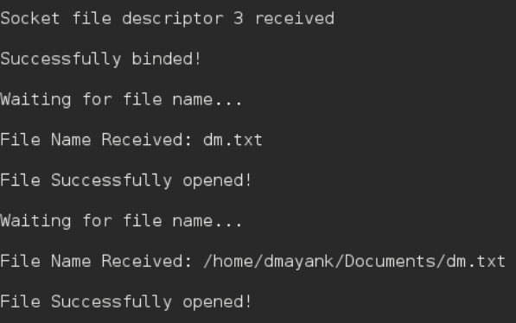

# Client side:

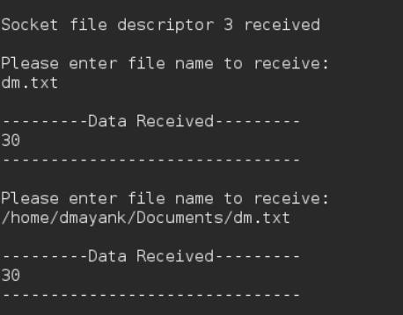

**VIVA VOICE:**

# What is the UDP?

1. UDP is a connectionless transport protocol that provides low-latency, but no reliability or error correction.
2. **What are the features of UDP?**
3. UDP features include connectionless transmission, low overhead, lack of reliability and error correction, lack of congestion control, support for broadcast/multicast, simplicity, and suitability for real-time applications.

# What is the datagram?

1. A datagram is an independent packet of data that contains both the data and destination address for transmission over a network.
2. **Explain the process how the datagram flow does in UDP?**
3. In UDP, the application layer creates a datagram with the data to be transmitted, which is then sent to the transport layer. The transport layer encapsulates the datagram with the UDP header and sends it over the network to the destination address.

# Explain the advantages of UDP?

1. Advantages of UDP include low overhead and low latency, support for broadcast/multicast, simplicity, greater control over data transmission, and suitability for resource-constrained devices.
2. **What are the drawbacks of the UDP?**
3. Drawbacks of UDP include its lack of reliability and error correction, lack of congestion control, and vulnerability to security threats due to its connectionless nature.

# What is the operation is used in encryption in UDP?

1. Encryption in UDP is typically implemented using a secure encryption algorithm such as AES (Advanced Encryption Standard). This involves encrypting the data within the UDP datagram before transmission to protect it from interception and unauthorized access.

**Week - 10 IPC**

**Implement the following forms of IPC. a) Pipes b) FIFO AIM:** To implement the following forms of IPC a. Pipes b. FIFO. **DESCRIPTION:**

# Pipes

Pipe is a communication medium between two or more related or interrelated processes. It can be either within one process or a communication between the child and the parent processes. Communication can also be multi-level such as communication between the parent, the child and the grand-child, etc. Communication is achieved by one process writing into the pipe and other reading from the pipe. To achieve the pipe system call, create two files, one to write into the file and another to read from the file.

Pipe mechanism can be viewed with a real-time scenario such as filling water with the pipe into some container, say a bucket, and someone retrieving it, say with a mug. The filling process is nothing but writing into the pipe and the reading process is nothing but retrieving from the pipe. This implies that one output (water) is input for the other (bucket).

Pipe communication is viewed as only one-way communication i.e., either the parent process writes and the child process reads or vice-versa but not both. However, what if both the parent and the child needs to write and read from the pipes simultaneously, the solution is a two-way communication using pipes. Two pipes are required to establish two-way communication.

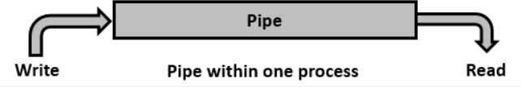

This system call would create a pipe for one-way communication i.e., it creates two descriptors, first one is connected to read from the pipe and other one is connected to write into the pipe.

Descriptor pipedes[0] is for reading and pipedes[1] is for writing. Whatever is written into pipedes[1] can be read from pipedes[0].

This call would return zero on success and -1 in case of failure. To know the cause of failure, check with errno variable or perror() function.

# Algorithm

**Step 1** − Create a pipe.

**Step 2** − Create a child process.

**Step 3** − Parent process writes to the pipe.

**Step 4** − Child process retrieves the message from the pipe and writes it to the standard output.

**Step 5** − Repeat step 3 and step 4 once again.

# PROGRAM:

#include<stdio.h> #include<unistd.h> int main() {

int pipefds[2]; int returnstatus; int pid;

char writemessages[2][20]={"Hi", "Hello"}; char readmessage[20];

returnstatus = pipe(pipefds); if (returnstatus == -1) {

printf("Unable to create pipe\n"); return 1;

}

pid = fork(); if (pid == 0) {

read(pipefds[0], readmessage, sizeof(readmessage));

printf("Child Process - Reading from pipe – Message 1 is %s\n", readmessage); read(pipefds[0], readmessage, sizeof(readmessage));

printf("Child Process - Reading from pipe – Message 2 is %s\n", readmessage);

} else { //Parent process

printf("Parent Process - Writing to pipe - Message 1 is %s\n", writemessages[0]); write(pipefds[1], writemessages[0], sizeof(writemessages[0]));

printf("Parent Process - Writing to pipe - Message 2 is %s\n", writemessages[1]); write(pipefds[1], writemessages[1], sizeof(writemessages[1]));

}

return 0;

}

# OUTPUT:

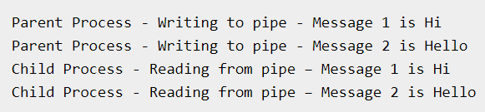

**DESCRIPTION:**

# FIFO

Pipes were meant for communication between related processes. Can we use pipes for unrelated process communication, say, we want to execute client program from one terminal and the server program from another terminal? The answer is No. Then how can we achieve unrelated processes communication, the simple answer is Named Pipes. Even though this works for related processes, it gives no meaning to use the named pipes for related process communication.

We used one pipe for one-way communication and two pipes for bi-directional communication. Does the same condition apply for Named Pipes. Another name for named pipe is **FIFO (First-In-First-Out)**. Let us see the system call (mknod()) to create a named pipe, which is a kind of a special file.

This system call would create a special file or file system node such as ordinary file, device file, or FIFO. The arguments to the system call are pathname, mode and dev. The pathname along with the attributes of mode and device information. The pathname is relative, if the directory is not specified it would be created in the current directory. The mode specified is the mode of file which specifies the file type such as the type of file and the file mode as mentioned in the following tables. The dev field is to specify device information such as major and minor device numbers.

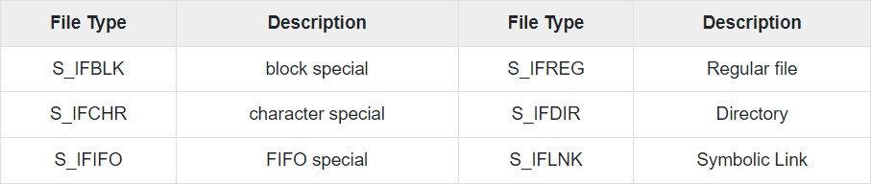

File mode can also be represented in octal notation such as 0XYZ, where X represents owner, Y represents group, and Z represents others. The value of X, Y or Z can range from 0 to 7. The values for read, write and execute are 4, 2, 1 respectively. If needed in combination of read, write and execute, then add the values accordingly.

Say, if we mention, 0640, then this means read and write (4 + 2 = 6) for owner, read (4) for group and no permissions (0) for others.

This call would return zero on success and -1 in case of failure. To know the cause of failure, check with errno variable or perror() function.

# PROGRAM:

#include <stdio.h> #include <sys/stat.h> #include <sys/types.h> #include <fcntl.h> #include <unistd.h> #include <string.h>

#define FIFO_FILE "MYFIFO"

int main() { int fd;

int end_process; int stringlen; char readbuf[80]; char end_str[5];

printf("FIFO_CLIENT: Send messages, infinitely, to end enter \"end\"\n"); fd = open(FIFO_FILE, O_CREAT|O_WRONLY);

strcpy(end_str, "end");

while (1) {

printf("Enter string: "); fgets(readbuf, sizeof(readbuf), stdin); stringlen = strlen(readbuf); readbuf[stringlen - 1] = '\0';

end_process = strcmp(readbuf, end_str);

//printf("end_process is %d\n", end_process); if (end_process != 0) {

write(fd, readbuf, strlen(readbuf));

printf("Sent string: \"%s\" and string length is %d\n", readbuf, (int)strlen(readbuf));

} else {

write(fd, readbuf, strlen(readbuf));

printf("Sent string: \"%s\" and string length is %d\n", readbuf, (int)strlen(readbuf)); close(fd);

break;

}

}

return 0;

}

# OUTPUT:

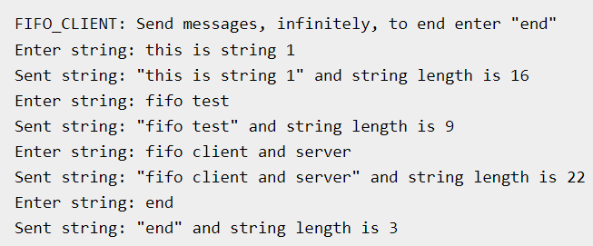

**VIVA VOICE:**

# What is IPC stands for? Explain IPC.

1. IPC stands for Interprocess Communication, which refers to the mechanisms and techniques used by operating systems to allow different processes to communicate with each other. IPC enables processes to share resources and coordinate their activities, leading to more efficient and effective software systems.
   1. **What are the different forms of IPC?**
2. The different forms of IPC include shared memory, message passing, pipes and sockets, remote procedure calls (RPC), and semaphores. Each form of IPC has its own strengths and weaknesses and is used in different scenarios depending on the requirements of the application.

# What is use of the IPC?

1. IPC is used to enable communication and data exchange between different processes or threads in a system, allowing them to coordinate their activities, share resources, and perform complex tasks together. It enables the creation of more efficient and effective software systems, leading to improved performance, scalability, and reliability.
   1. **Explain about the pipes?**
2. Pipes are a form of IPC that provide a unidirectional communication channel between two processes. One process writes data to the pipe, and the other process reads it from the pipe. Pipes are a simple and efficient way to communicate between processes on the same system, but they are limited to one-way communication and can only be used between processes that have a common ancestor.

# Explain the 2-way communication in the pipe?

1. Two-way communication in pipes can be achieved by creating two pipes, one for each direction of communication. This allows two processes to communicate with each other in both directions, with one process writing data to one pipe and reading data from the other pipe, while the other process does the opposite.
   1. **What is FIFO in IPC?**
2. FIFO is a named pipe that provides interprocess communication between processes on the same system.

# What is the functionality of the FIFO?

1. The functionality of FIFO is to provide a named pipe for interprocess communication between processes on the same system using a queue-based mechanism.

**Week - 11 IPC Continued**

**Implement file transfer using Message Queue form of IPC AIM:** To implement file transfer using Message Queue form of IPC **DESCRIPTION:**

once the message is received by a process it would be no longer available for any other process. Whereas in shared memory, the data is available for multiple processes to access.

If we want to communicate with small message formats. Shared memory data need to be protected with synchronization when multiple processes communicating at the same time. Frequency of writing and reading using the shared memory is high, then it would be very complex to implement the functionality.

What if all the processes do not need to access the shared memory but very few processes only need it, it would be better to **implement with message queues.** If we want to communicate with different data packets, say process A is sending message type 1 to process B, message type 10 to process C, and message type 20 to process D. In this case, it is simplier to implement with message queues. To simplify the given message type as 1, 10, 20, it can be either 0 or +ve or –ve as discussed below.

Of course, the order of message queue is FIFO (First In First Out). The first message inserted in the queue is the first one to be retrieved. Using Shared Memory or Message Queues depends on the need of the application and how effectively it can be utilized.

Communication using message queues can happen in the following ways −

* Writing into the shared memory by one process and reading from the shared memory by another process. As we are aware, reading can be done with multiple processes as well.

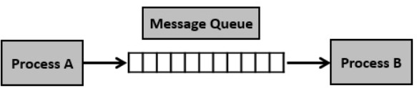

* 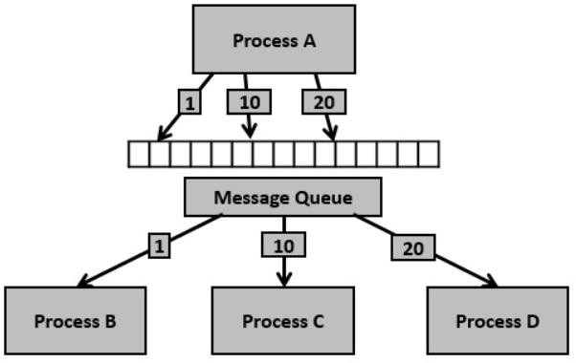Writing into the shared memory by one process with different data packets and reading from it by multiple processes, i.e., as per message type.

# PROGRAM:

#include <stdio.h> #include <sys/ipc.h> #include <sys/msg.h>

// structure for message queue struct msg_buffer {

long msg_type; char msg[100];

} message; main() {

key_t my_key; int msg_id;

my_key = ftok("progfile", 65); //create unique key

msg_id = msgget(my_key, 0666 | IPC_CREAT); //create message queue and return id message.msg_type = 1;

printf("Write Message : "); fgets(message.msg, 100, stdin);

msgsnd(msg_id, &message, sizeof(message), 0); //send message printf("Sent message is : %s \n", message.msg);

}

# OUTPUT:

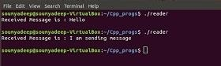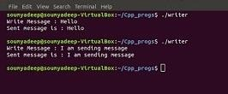

**VIVA VOICE:**

# What is IPC stands for? Explain IPC.

1. IPC stands for Interprocess Communication, which refers to the mechanisms and techniques used by operating systems to enable different processes to communicate with each other, share resources, and coordinate their activities, leading to more efficient and effective software systems.
2. **What are the different forms of IPC?**
3. The different forms of IPC include shared memory, message passing, pipes and sockets, remote procedure calls (RPC), and semaphores. Each form of IPC has its own strengths and weaknesses and is used in different scenarios depending on the requirements of the application.

# What is use of the IPC?

1. The main use of IPC is to enable communication and data exchange between different processes or threads in a system, allowing them to coordinate their activities, share resources, and perform complex tasks together. This enables the creation of more efficient and effective software systems, leading to improved performance, scalability, and reliability.
2. **Explain about the message queues?**
3. Message queues are a form of IPC that allow processes to communicate by passing messages through a queue. The sender places a message in the queue, and the receiver retrieves it from the queue, providing reliable and ordered delivery of messages.

# Explain why we need shared memory?

1. Shared memory is needed to allow multiple processes to access the same region of memory, enabling efficient communication and sharing of data between processes.
2. **What is difference between shared memory and message queue?**
3. Shared memory allows direct access to a region of memory shared between processes, while message queues provide a mechanism for sending and receiving messages between processes using a message buffer in memory.

# What is the functionality of the message queues?

1. The functionality of message queues is to enable reliable and ordered communication between processes using a message buffer in memory.

**Week - 12 RPC**

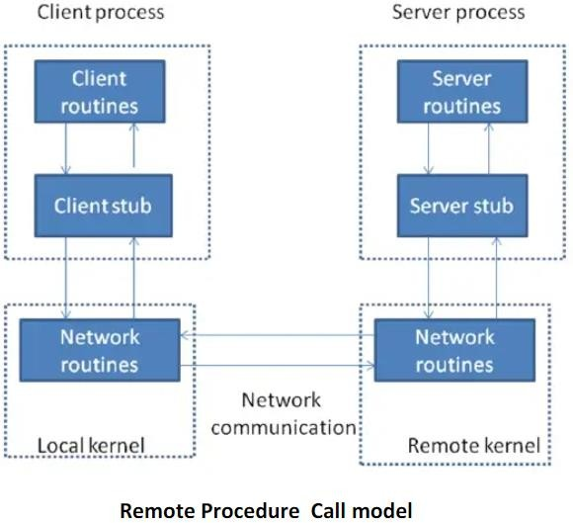**Design a RPC application to add and subtract a given pair of integers AIM:** To design a RPC application to add and subtract a given pair of integers **DECRIPTION:**

The steps in the Figure Remote Procedure Call ( RPC ) Model are.

* + The client calls a local procedure, called the clients stub. It appears to the client that the client stub is the actual server procedure that it wants to call. the purpose of the stub is to package up the arguments to the remote procedure, possibly put them into some standard format and then build one or more network messages. The packaging of the clients arguments into a network message is termed marshaling.
  + These network messages are sent to the remote system by the client stub. This requires a system call into the kernel. The network messages are transferred to the remote system. Either a connection-oriented or a connectionless protocol is used.
  + A Server stub procedure is waiting on the remote system for the client’s request. It unmartial the arguments from the network messages and possibly converts them.
  + The server stub executes a local procedure call to invoke the actual server function, passing it the arguments that it received in the network messages from the clients tub.
  + When the server procedure is finished, it returns to the server stub, returning whatever its return values are. The server stub converts the return values, if necessary and marshals them into one or more network messages to send back to the client stub.
  + To message get transferred back across the network to client stub. The client stub reads the network message from the local kernel.
  + After possibly converting the return values the client stub finally returns to the client functions this appears to be a normal procedure returns to the client

# PROGRAM:

#include "rpctime.h" #include <stdio.h> #include <stdlib.h>

#include <rpc/pmap_clnt.h> #include <string.h> #include <memory.h> #include <sys/socket.h> #include <netinet/in.h> #ifndef SIG_PF

#define SIG_PF void(*)(int) #endif

static void

rpctime_1(struct svc_req *rqstp, register SVCXPRT *transp)

{

union {int fill;

} argument; char *result;

xdrproc_t _xdr_argument, _xdr_result; char *(*local)(char *, struct svc_req *); switch (rqstp->rq_proc) {

case NULLPROC:(void) svc_sendreply (transp, (xdrproc_t) xdr_void, (char *)NULL); return;

case GETTIME:

_xdr_argument = (xdrproc_t) xdr_void;

_xdr_result = (xdrproc_t) xdr_long;

local = (char *(*)(char *, struct svc_req *)) gettime_1_svc; break;

default:

svcerr_noproc (transp); return;

}

memset ((char *)&argument, 0, sizeof (argument));

if (!svc_getargs (transp, (xdrproc_t) _xdr_argument, (caddr_t) &argument)) { svcerr_decode (transp);

return;

}

result = (*local)((char *)&argument, rqstp);

if (result != NULL && !svc_sendreply(transp, (xdrproc_t) _xdr_result, result)) { svcerr_systemerr (transp);

}

if (!svc_freeargs (transp, (xdrproc_t) _xdr_argument, (caddr_t) &argument)) { fprintf (stderr, "%s", "unable to free arguments");

exit (1);

}

return;

}

intmain (int argc, char **argv){ register SVCXPRT *transp;

pmap_unset (RPCTIME, RPCTIMEVERSION);

transp = svcudp_create(RPC_ANYSOCK); if (transp == NULL) {

fprintf (stderr, "%s", "cannot create udp service."); exit(1);

}

if (!svc_register(transp, RPCTIME, RPCTIMEVERSION, rpctime_1, IPPROTO_UDP)) {

fprintf (stderr, "%s", "unable to register (RPCTIME, RPCTIMEVERSION,udp)."); exit(1);

}

transp = svctcp_create(RPC_ANYSOCK, 0, 0);if (transp == NULL) { fprintf (stderr, "%s", "cannot create tcp service.");

exit(1);

}

if (!svc_register(transp, RPCTIME, RPCTIMEVERSION, rpctime_1, IPPROTO_TCP)) { fprintf (stderr, "%s", "unable to register (RPCTIME, RPCTIMEVERSION, tcp)."); exit(1);

}

svc_run ();

fprintf (stderr, "%s", "svc_run returned"); exit (1);

}

**Client Side:**

#include "rpctime.h" voidrpctime_1(char *host){ CLIENT *clnt;47long *result_1; char *gettime_1_arg;

#ifndef DEBUGclnt = clnt_create (host, RPCTIME, RPCTIMEVERSION, "udp"); if (clnt == NULL) {

clnt_pcreateerror (host); exit (1);

}

#endif /* DEBUG */

result_1 = gettime_1((void*)&gettime_1_arg, clnt); if (result_1 == (long *) NULL) {

clnt_perror (clnt, "call failed");

}

Else

printf("%d |%s", *result_1, ctime(result_1)); #ifndef DEBUGclnt_destroy (clnt);

#endif /* DEBUG */}

intmain (int argc, char *argv[]){ char *host;

if (argc < 2) {

printf ("usage: %s server_host\n", argv[0]); exit (1);

}

host = argv[1]; rpctime_1 (host); exit (0);

}

rpctime_cntl.c

#include <memory.h> /* for memset */

#include "rpctime.h"/* Default timeout can be changed using clnt_control() */ static struct timeval TIMEOUT = { 25, 0 };

long *

gettime_1(void *argp, CLIENT *clnt){

static long clnt_res;memset((char *)&clnt_res, 0, sizeof(clnt_res));

if (clnt_call (clnt, GETTIME,(xdrproc_t) xdr_void, (caddr_t) argp,(xdrproc_t) xdr_long, (caddr_t) &clnt_res,TIMEOUT) != RPC_SUCCESS) {

return (NULL);

}

return (&clnt_res);

}

# OUTPUT:

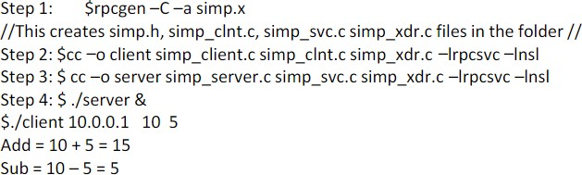

**VIVA VOICE:**

# What is RPC stands for? Explain RPC.

1. RPC stands for Remote Procedure Call, which is a protocol used in distributed computing to enable a program running on one computer to call a subroutine or function on a remote computer, as if it were a local function call, allowing for seamless inter-process communication.
2. **What are the applications of RPC?**
3. RPC is commonly used in distributed systems such as client-server architectures, where the server provides services to multiple clients, as well as in web-based applications, cloud computing, and other distributed computing environments. RPC is also used in high-performance computing, scientific simulations, and other compute-intensive applications.

# What is use of the RPC?

1. RPC simplifies development of distributed systems and enables scalability and fault tolerance.
2. **Explain about the functionality of RPC?**
3. RPC enables remote procedure calls across a network, handling the complexities of network communication and making it easier to build distributed applications.

# Explain why we need RPC?

# RPC allows for seamless communication between processes running on different machines, reducing the complexity of distributed systems and enabling better scalability and fault tolerance. This makes it easier to build complex applications that span multiple machines and network

**Week – 13 ECC**

# Write a C Program to implement Elliptic Curve Cryptographic Algorithm

# AIM: To implement Elliptic Curve Cryptographic Algorithm

# Description:

# Elliptic Curve Cryptography (ECC) is a key-based technique for encrypting data. ECC focuses on pairs of public and private keys for decryption and encryption of web traffic. ECC is frequently discussed in the context of the Rivest–Shamir–Adleman (RSA) cryptographic algorithm. An elliptic curve is not an ellipse, or oval shape, but it is represented as a looping line intersecting two axes, which are lines on a graph used to indicate the position of a point. The curve is completely symmetric, or mirrored, along the x-axis of the graph.

# Public key cryptography systems, like ECC, use a mathematical process to merge two distinct keys and then use the output to encrypt and decrypt data. One is a public key that is known to anyone, and the other is a private key that is only known by the sender and receiver of the data.

# ECC generates keys through the properties of an elliptic curve equation instead of the traditional method of generation as the product of large prime numbers. From a cryptographic perspective, the points along the graph can be formulated using the following equation:

# y²=x³ + ax + b

# ECC is like most other public key encryption methods, such as the RSA algorithm and Diffie-Hellman. Each of these cryptography mechanisms uses the concept of a one-way, or trapdoor, function. This means that a mathematical equation with a public and private key can be used to easily get from point A to point B. But, without knowing the private key and depending on the key size used, getting from B to A is difficult, if not impossible, to achieve.

# ECC is based on the properties of a set of values for which operations can be performed on any two members of the group to produce a third member, which is derived from points where the line intersects the axes as shown with the green line and three blue dots in the below diagram labeled A, B and C. Multiplying a point on the curve by a number produces another point on the curve (C). Taking point C and bringing it to the mirrored point on the opposite side of the x-axis produces point D. From here, a line is drawn back to our original point A, creating an intersection at point E. This process can be completed n number of times within a defined max value. The n is the private key value, which indicates how many times the equation should be run, ending on the final value that is used to encrypt and decrypt data. The maximum defined value of the equation relates to the key size used.

# PROGRAM

#include <stdio.h>

#include <stdlib.h>

#include <math.h>

//Information about the curve and finite field

int a=4;//coefficient for elliptic curve

int b=20;//coefficient for elliptic curve

int p=29;//prime number to provide finite field

int points[1000][2];//to store a set of points satisfying the curve

//Information required for Encryption and Decryption

//Private Information

int PrivKey=11;//Private Key of Receiver

//Public Information

int PubKey[2]={0,0};//Public key of Receiver

int random=11;//Random Number required for Encoding

int Pbase[2]={0,0};//Base point for all operations

//Encrypted Point

int Enc[4]={0,0,0,0};

//Functions Used

int * sclr_mult(int k,int point[2]);

int * add(int A[2],int B[2]);

int inverse(int num);

int * encode(int m,int Pb[2],int random,int Pbase[2]);//(Message,Public Key)

int * genKey(int X,int P[2]);//(Private Key,Base Point)

int decode(int Enc[4],int PrivKey);//(Encrypted Message, Private key of the Receiver) Outputs Message

void generate();

int main()

{

int *temp;

generate();

Pbase[0]=points[5][0];//Deciding the base point here

Pbase[1]=points[5][1];

temp=genKey(PrivKey,Pbase);

PubKey[0]=*temp;

PubKey[1]=*(temp+1);

printf("\nThe Public Key is (%d,%d)\n",PubKey[0],PubKey[1]);

int message[2];

message[0]=points[5][0];

message[1]=points[5][1];

printf("The message point is (%d,%d)\n",message[0],message[1]);

int P[2];

temp=sclr_mult(random,Pbase);

P[0]=*temp;

P[1]=*(temp+1);

int Q[2];

temp=sclr_mult(random,PubKey);

Q[0]=*temp;

Q[1]=*(temp+1);

int R[2];

temp=add(message,Q);

R[0]=*temp;

R[1]=*(temp+1);

printf("The encrypted point is [(%d,%d),(%d,%d)]\n",P[0],P[1],R[0],R[1]);

temp=sclr_mult(PrivKey,P);

int O[2];

O[0]=*temp;

O[1]=p-*(temp+1);

temp=add(R,O);

O[0]=*temp;

O[1]=*(temp+1);

printf("The message point is (%d,%d)\n",O[0],O[1]);

return 0;

}

int * sclr_mult(int k,int P[2])//using LSB first algorithm

{

int *temp,i;

int *Q = calloc(2,sizeof(int));

Q[0]=0;

Q[1]=0;

for(i=31;i>=0;i--)

{

if((k>>i)&1)

break;

}

for(int j=0;j<=i;j++)

{

if((k>>j)&1)

{

temp=add(Q,P);

Q[0]=*temp;

Q[1]=*(temp+1);

}

temp=add(P,P);

P[0]=*temp;

P[1]=*(temp+1);

}

return Q;

}

int * add(int A[2],int B[2])

{

int *C = calloc(2,sizeof(int));

int x=0;

if (A[0]==0 || A[1]==0)

{

return B;

}

if (B[0]==0 || B[1]==0)

{

return A;

}

if (A[1]==(p-B[1]))

{

return C;

}

if ((A[0]==B[0]) && (A[1]==B[1]))

{

x=((3*(A[0]*A[0]))+a)*inverse(2*A[1]);

C[0]=((x*x)-(2*A[0]))%p;

C[1]=((x*(A[0]-C[0]))-A[1])%p;

//C[0]=((A[0]*A[0])%p+(b*inverse(A[0]*A[0]))%p)%p;//For Binary Curves

//C[1]=((A[0]*A[0])%p+((A[0]+(A[1]*inverse(A[0]))*C[0]))%p+(C[0])%p)%p;//For Binary Curves

}

else

{

x=(B[1]-A[1])*inverse(B[0]-A[0]);

C[0]=((x*x)-(A[0]+B[0]))%p;

C[1]=((x*(A[0]-C[0]))-A[1])%p;

//C[0]=((((A[1]+B[1])*inverse(A[0]+B[0]))*((A[1]+B[1])*inverse(A[0]+B[0])))%p + ((A[1]+B[1])*inverse(A[0]+B[0]))%p + A[0]%p + B[0]%p + a%p)%p;//For Binary Curves

//C[1]=((((A[1]+B[1])*inverse(A[0]+B[0]))*(A[0]+C[0]))+C[0]+A[1])%p;//For Binary Curves

}

if (C[0]<0)

C[0]=p+C[0];

if (C[1]<0)

C[1]=p+C[1];

return C;

}

int inverse(int num)

{

int i=1;

if (num<0)

num=p+num;

for (i=1;i<p;i++)

{

if(((num*i)%p)==1)

break;

}

//printf("inverse=%d,%d",i,num);

return i;

}

void generate()

{

int rhs,lhs,i=0;//to find set of points that satisfy the elliptic curve

for(int x=0;x<p;x++)

{

rhs=((x*x*x)+(a*x)+b)%p;

for(int y=0;y<p;y++)

{

lhs=(y*y)%p;

if (lhs==rhs)

{

points[i][0]=x;

points[i][1]=y;

i+=1;

}

}

}

printf("\nNumber of points found on the curve is %d \n",i);

for(int k=0;k<i;k++)

{

printf("%d(%d,%d)\n",(k),points[k][0],points[k][1]);

}

}

int * genKey(int X,int P[2])

{

int *temp;

int *Q = calloc(2,sizeof(int));

temp=sclr_mult(X,P);

Q[0]=*temp;

Q[1]=*(temp+1);

return Q;

}

**VIVA VOICE:**

# What does ECC stands for? Explain ECC.

# Elliptic curve cryptography (ECC) is a public key cryptographic algorithm used to perform critical security functions, including encryption, authentication, and digital signatures.

# What is the key size of ECC?

# With a 112-bit strength, the ECC key size is 224 bits and the RSA key size is 2048 bits.

# What is the formula for Elliptic Curve?

# In most situations, an Elliptic Curve E is the graph of an equation of the form y2 = x3 + Ax + B, where A and B are constants. This is called the Weierstrass equation for an elliptic curve.

# What are the attacks on ECC?

# ECC (Elliptic Curve Cryptography) is used as a public key crypto system with the key purpose of creating a private shared between two participants in a communication network. Attacks on ECC include the Pohlig-Hellman attack and the Pollard's rho attack.

# What is the most used Elliptic Curve?

# The most popular (preferred) elliptic curve is NIST P-256, followed by X25519.

**Week - 14**

**Write a C Program to implement Eucledian Algorithm to find GCD.**

**AIM:** To implement the Eucledian Algorithm to find GCD.

**DESCRIPTION:**

The Euclidean Algorithm is a technique for quickly finding the GCD of two integers.

The Euclidean Algorithm for finding GCD(A,B) is as follows:

If A = 0 then GCD(A,B)=B, since the GCD(0,B)=B, and we can stop.

If B = 0 then GCD(A,B)=A, since the GCD(A,0)=A, and we can stop.

Write A in quotient remainder form (A = B⋅Q + R)

Find GCD(B,R) using the Euclidean Algorithm since GCD(A,B) = GCD(B,R)

**PROGRAM**:

#include <stdio.h>

void main() {

    int m, n; /* given numbers */

    clrscr();

    printf("Enter-two integer numbers: ");

    scanf ("%d %d", &m, &n);

    while (n > 0) {

        int r = m % n;

        m = n;

        n = r;

    }

    printf ("GCD = %d \n",m);

    getch();

}

**OUTPUT:**

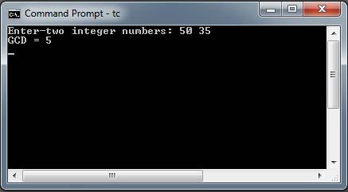

# VIVA VOCE

# Which algorithm is most efficient for GCD?

# In mathematics, the Euclidean algorithm, or Euclid's algorithm, is an efficient method for computing the greatest common divisor (GCD) of two integers (numbers), the largest number that divides them both without a remainder.

# What is an improved variant of the Euclid’s algorithm for GCD?

Improved Euclidean algorithm: gcd(a, b) = gcd(a, r), where r is any integer congruent to b (mod a). For

example, r could be the remainder when b is divided by a.

# How many methods are there to find the GCD?

# The greatest common divisor (gcd) of two integers, a and b, is the largest integer that divides evenly into both a and b. We write gcd(a, b). There are three methods for finding the greatest common factor. When there are no more digits to bring down, the final difference is the remainder.

# What is the Euclidean algorithm named after?

# It is named after the Greek mathematician Euclid, who described it in Books VII and X of his Elements."

# How many solutions does the Euclidean algorithm provide?

# But in fact these equations have infinitely many solutions, and the extended Euclidean algorithm can be used to generate as many of these solutions as we like.

**Week – 15**

# Write a C Program to implement NSA Digital Signature Algorithm

# AIM: to implement NSA Digital Signature Algorithm

# Description:

# Importance of Digital Signature

# The importance of digital signatures is not negligible in this digital world, and there are some,

# Ensures Authenticity: Digital signatures ensure the authenticity of a message or transaction by proving that the message or signature was created using the private key associated with the digital signature.

# Offers Non-repudiation: A digital signature provides an entire record that a specific individual signed the document or transaction at a particular time. This feature prevents the individual from denying that they signed it.

# Provides Security: Digital signatures use encryption algorithms to protect the data from unauthorized access and tampering. The cryptographic techniques used by digital signatures also protect the data from being changed or manipulated during transmission.

# Improves Efficiency: Digital signatures can reduce the time and money spent on paperwork, printing, scanning, and mailing documents.

# Role of Digital Signatures

# Digital signatures are used for authentication or verification. They are used to verify the authenticity and integrity of a digital document or message.

# The prominent role of a digital signature is to ensure the integrity and authenticity of a digital document or message. A digital signature is essentially a type of electronic signature which provides non-repudiation and authentication between two parties. It serves as proof that the two parties have agreed to specific terms and conditions and have mutually verified the contents of a document or message.

# Digital signatures can also protect confidential information, ensuring that only authorized persons can access the data.

# DSA Algorithm provides three benefits, which are as follows:

# Message Authentication: You can verify the origin of the sender using the right key combination.

# Integrity Verification: You cannot tamper with the message since it will prevent the bundle from being decrypted altogether.

# Non-repudiation: The sender cannot claim they never sent the message if verifies the signature.

# PROGRAM

# #include <stdio.h>

# #include <windows.h>

# #include <Wincrypt.h>

# #define MY_ENCODING_TYPE (PKCS_7_ASN_ENCODING | X509_ASN_ENCODING)

# void MyHandleError(char *s);

# void main()

# {

# // Declare and initialize variables.

# DATA_BLOB DataIn;

# DATA_BLOB DataOut;

# DATA_BLOB DataVerify;

# BYTE *pbDataInput =(BYTE *)"Hello world of data protection.";

# DWORD cbDataInput = strlen((char *)pbDataInput)+1;

# DataIn.pbData = pbDataInput;

# DataIn.cbData = cbDataInput;

# CRYPTPROTECT_PROMPTSTRUCT PromptStruct;

# LPWSTR pDescrOut = NULL;

# / Begin processing.

# printf("The data to be encrypted is: %s\n",pbDataInput);

# // Initialize PromptStruct.

# ZeroMemory(&PromptStruct, sizeof(PromptStruct));

# PromptStruct.cbSize = sizeof(PromptStruct);

# PromptStruct.dwPromptFlags = CRYPTPROTECT_PROMPT_ON_PROTECT;

# PromptStruct.szPrompt = L"This is a user prompt.";

# if(CryptProtectData(

# &DataIn,

# L"This is the description string.", // A description string.

# NULL, // Optional entropy

# // not used.

# NULL, // Reserved.

# &PromptStruct, // Pass a PromptStruct.

# 0,

# &DataOut))

# {

# printf("The encryption phase worked. \n");

# }

# else

# {

# MyHandleError("Encryption error!");

# }

# if (CryptUnprotectData(

# &DataOut,

# &pDescrOut,

# NULL, // Optional entropy

# NULL, // Reserved

# &PromptStruct, // Optional PromptStruct

# 0,

# &DataVerify))

# {

# printf("The decrypted data is: %s\n", DataVerify.pbData);

# printf("The description of the data was: %S\n",pDescrOut);

# }

# else

# {

# MyHandleError("Decryption error!");

# } LocalFree(pDescrOut);

# LocalFree(DataOut.pbData);

# LocalFree(DataVerify.pbData);

# } // End of main

# VIVA VOCE

# What is Digital Signature?

# It is a mathematical process known as a digital signature, a sort of electronic signature that is frequently used to verify the integrity and authenticity of a message (For e.g., Used in a credit card transaction, while writing an email, or in a digital document).

# What is the algorithm for a digital signature?

# A person who electronically signs a document uses their private key, which they keep safe at all times, to create the signature. The mathematical approach creates data that matches the signed document, known as a hash, and encrypts that data, acting as a cipher.

# Why is the DSA algorithm used?

# Digital Signature Algorithm is what DSA stands for. It serves as a means of verifying digital signatures. It is based on the discrete logarithm and modular exponentiation mathematical concepts. In 1991, the National Institute of Standards and Technology (NIST) developed it.

# Which is the fastest digital signature algorithm?

# EdDSA (Edwards-curve Digital Signature Algorithm) is a fast digital signature algorithm.

# What is the most common method for generating digital signatures?

# The most common way of creating a digital signature is to use Public Key Cryptography (PKC). Public Key Infrastructures (PKI) are used to deliver PKC. At a basic level, digital signature solutions require each user to have a public and private key pair which are mathematically linked.

# WEEK-16

# Write a program to create an integer variable using shared memory concept and increment the variable simultaneously by two processes. Use semaphores to avoid race conditions

# AIM: To create an integer variable using shared memory concept and increment the variable simultaneously by two processes. Use semaphores to avoid race conditions.

# DESCRIPTION

# Shared memory system is the fundamental model of inter process communication. In a shared memory system, in the address space region the cooperating communicate with each other by establishing the shared memory region.Shared memory concept works on fastest inter process communication.If the process wants to initiate the communication and it has some data to share, then establish the shared memory region in its address space. After that, another process wants to communicate and tries to read the shared data, and must attach itself to the initiating process’s shared address space.Let us see the working condition of the shared memory system step by step.

# WORKING

# In the Shared Memory system, the cooperating processes communicate, to exchange the data with each other. Because of this, the cooperating processes establish a shared region in their memory. The processes share data by reading and writing the data in the shared segment of the processes.

# https://www.tutorialspoint.com/assets/questions/media/60290/two%20processes.jpg

**Step 1**− Process P1 has some data to share with process P2. First P1 takes initiative and establishes a shared memory region in its own address space and stores the data or information to be shared in its shared memory region.

**Step 2**− Now, P2 requires the information stored in the shared segment of P1. So, process P2 needs to attach itself to the shared address space of P1. Now, P2 can read out the data from there.

**Step 3**− The two processes can exchange information by reading and writing data in the shared segment of the process.

# PROGRAM

# #include<pthread.h>

# #include<stdio.h>

# #include<semaphore.h>

# #include<unistd.h>

# void *fun1();

# void *fun2();

# int shared=1; //shared variable

# sem_t s; //semaphore variable

# int main()

# {

# sem_init(&s,0,1); //initialize semaphore variable - 1st argument is address of variable, 2nd is number of processes sharing semaphore, 3rd argument is the initial value of semaphore variable

# pthread_t thread1, thread2;

# pthread_create(&thread1, NULL, fun1, NULL);

# pthread_create(&thread2, NULL, fun2, NULL);

# pthread_join(thread1, NULL);

# pthread_join(thread2,NULL);

# printf("Final value of shared is %d\n",shared); //prints the last updated value of shared variable

# }

# void *fun1()

# {

# int x;

# sem_wait(&s); //executes wait operation on s

# x=shared;//thread1 reads value of shared variable

# printf("Thread1 reads the value as %d\n",x);

# x++; //thread1 increments its value

# printf("Local updation by Thread1: %d\n",x);

# sleep(1); //thread1 is preempted by thread 2

# shared=x; //thread one updates the value of shared variable

# printf("Value of shared variable updated by Thread1 is: %d\n",shared);

# sem_post(&s);

# }

# void *fun2()

# {

# int y;

# sem_wait(&s);

# y=shared;//thread2 reads value of shared variable

# printf("Thread2 reads the value as %d\n",y);

# y--; //thread2 increments its value

# printf("Local updation by Thread2: %d\n",y);

# sleep(1); //thread2 is preempted by thread 1

# shared=y; //thread2 updates the value of shared variable

# printf("Value of shared variable updated by Thread2 is: %d\n",shared);

# sem_post(&s);

# }

# OUTPUT

# Program for Process Synchronization using Semaphores

# VIVA VOCE

# Why do we use shared memory in OS?

# Shared memory is a faster inter process communication system. It allows cooperating processes to access the same pieces of data concurrently. It speeds up the computation power of the system and divides long tasks into smaller sub-tasks and can be executed in parallel. Modularity is achieved in a shared memory system.

# What kernel supports shared memory?

# The Linux kernel supports POSIX shared memory through a special filesystem called tmpfs , which is mounted on to /dev/shm of the rootfs . This implementation offers a distinct API which is consistent with the Unix file model, resulting in each shared memory allocation to be represented by a unique filename and inode.

# What are the two processes using shared memory?

# Two functions shmget() and shmat() are used for IPC using shared memory. shmget() function is used to create the shared memory segment, while the shmat() function is used to attach the shared segment with the process's address space.

# How is shared memory allocated?

# The database server creates portions in shared memory to handle different processes. If the sqlhosts file specifies shared-memory communications, the database server allocates memory for the communications portion.